

Voice Controlled Application For Finance (Finansis)

Student ID: 18511510019

name: Mohamed Mohamud Mohamed Nur

Major: Computer science and Technology

College: College of Computer science and Artificial Intelligence

MOAHEMD MOAHMUD MOHAMED NUR 18511510019 of 2018 CS

College of Computer and Artificial Intelligence

A thesis submitted in partial satisfaction of the requirements

For The Degree of Bachelor in

Computer Science and Technology

Supervisor WU WINGO

May 2022

I Mohamed NUR with student id 18511510019 hereby declare that the Work presented in this thesis is original and carried out by myself, under the supervisor of WU WINGO, and with the help of people that provide free information on the internet (stack-overflow and YouTube) during the period 11 /2021 - 5/2022. This work presented in this thesis has not been submitted for any other degree.

ABSTRACT

Voice assistant a software agent that can perform tasks or services for an individual based on commands or questions, This project is voice assistant named Finansis, This project aims to develop a voice assistant for finance. This application is inspired by Siri, (Siri is a virtual assistant that is part of Apple Inc.'s iOS) . Finansis developed for traders or normal people that interested in the stock market. The system is a web application that can be accessed through the internet. This system can be used for knowing the stock market news (real-time news), knowing current a stock price (real-time price), knowing stock information, showing a stock chart, asking questions related to the stock market, back-testing a trading strategy, and the most interesting is using Algorithmic Trading to trade stocks. This project is build using the MERN stack technologies (MongoDB, Express, React, Node).

**Keywords:** Voice assistant; Stock Market; Algorithmic Trading; Scraping; Automation.

TABLE OF CONTENTS

LIST OF TABLES i

LIST OF FIGURES iv

1 INTRODUCTION 1

1.1 System Development Environment Description 3

2 Literature review 5

2.1 Speech recognition 5

2.2 NLP 5

2.3 Speech synthesis 6

2.4 Algorithmic Trading 6

3 Technologies Used To Create Voice Assistant 7

3.1 Background info and pre-requisites 7

3.1.1 Introduction of NodeJS 7

3.1.2 Installation of NodeJS and NPM 7

3.1.3 Introduction of ReactJS 8

3.1.4 Creating ReactJS project using create-react-app 8

3.1.5 Introduction of react-speech-recognition 11

3.1.6 Installation of react-speech-recognition 11

3.1.7 Introduction of react-speech-kit 13

3.1.8 Installation of react-speech-kit 13

3.1.9 Your first voice assistant 16

3.1.10 18

4 REQUIREMENTS ANALYSIS 19

4.1 Functional requirement 19

5 SYSTEM DESIGN 22

5.1 System structure diagram 23

5.2 Data flow graph 24

5.2.1 The first data flow graph 24

5.2.2 The second data flow graph 24

5.2.3 The third data flow graph 25

5.3 Commands description: 30

5.3.1 User management commands (10): 30

5.3.2 Stock Market News commands (10): 30

5.3.3 Stock information commands (9): 31

5.3.4 controlling the app with a voice commands (5): 31

5.3.5 asking questions about the stock market commands: 31

5.3.6 back-testing stock trading strategy commands (4): 31

5.3.7 other commands (10): 32

5.3.8 automating stock trading commands (8): 32

6 SYSTEM PROBLEMS 53

7 Testing 56

8 Conclusion 79

8.1 Future Goals For The System overview 79

8.2 Drawback of Existing system 79

9 REFERENCE 80

LIST OF TABLES

Table 1 Register 19

Table 2 Log in 20

Table 3 forgot (my) password 21

Table 4 update my information 21

Table 5 logout 22

Table 6 logout 22

Table 7 add {Apple|AAPL|...} stock to (my) watch list 23

Table 8 delete {Apple|AAPL|...} stock from (my) watch list 24

Table 9 open (my) watch list 24

Table 10 Give me the news from {yahoo finance|investing|seekingalpha} 25

Table 11 Give me the news from {yahoo finance|investing|seekingalpha} 25

Table 12 what's up with {Apple|China|...} 26

Table 13 Give me the latest news 26

Table 14 read the news 26

Table 15 Give me more news 27

Table 16 start reading (news) from article {1|5|...} 27

Table 17 open article (number) {1|5|...} without control 28

Table 18 give me top stories 28

Table 19 logout 29

Table 20 open {Apple|AAPL|...} (symbol) chart 30

Table 21 give me {Apple|AAPL|...} statistics 30

Table 22 give me The most {actives|gainers|losers} stocks 31

Table 23 give me trending stocks 31

Table 24 open {Apple|AAPL|...} (symbol) chart with your control 32

Table 25 what is the current price for {Apple|AAPL|...} (symbol) 32

Table 26 show me {Apple and Tesla} charts 33

Table 27 go back 34

Table 28 go to {info|news|...} (page) 34

Table 29 close the window 34

Table 30 zoom {in|out} 35

Table 31 change the chart to {1 minute|1 hour|...} 35

Table 32 go forward 35

Table 33 open details page for the answer 36

Table 34 what is market capitalization 36

Table 35 back-testing stock trading strategy commands 37

Table 36 reset back testing (data) 37

Table 37 force sell 38

Table 38 sell with profit or without 38

Table 39 stock (number) {1|5|...} 39

Table 40 what can you do 39

Table 41 what is your name 39

Table 42 (of course) yes 39

Table 43 No 40

Table 44 do you have a boyfriend 40

Table 45 can you hear me 40

Table 46 stop listening 40

Table 47 thank you 41

Table 48 thank you 41

Table 49 buy stocks 42

Table 50 sell stocks 42

Table 51 set stop-loss for stocks 43

Table 52 find buy signals 43

Table 53 trade stocks for me 43

Table 54 show me (a) chart for found buy signals (stocks) 44

Table 55 show me (a) chart for found buy signals (stocks) 44

Table 56 show me trading progress 45

Table 14 User model 47

Table 15 applicant model 48

Table 16 Recruiter model 48

Table 17 Job model 50

Table 18 Rating model 51

Table 19 application model 52

Table 20 Applicant Registration 63

Table 21 Recruiter Registration 64

Table 22 User login 65

Table 23 adding job 66

Table 24 update job info 66

Table 25 viewing Applications 67

Table 26 System Operating Environment Requirements. 68

Table 27 Function1-division 75

Table 28 Function2-division 75

Table 29 Function3-division 75

LIST OF FIGURES

Figure 1 DFD-1 8

Figure 2 DFD-2FD-2 8

Figure 3 DFD (Back-Testing)-3-1 9

Figure 4 DFD (Questions)-3-2 10

Figure 8 DFD (Stock Info)-3-3 10

Figure 6 DFD (User Management)-3-4 11

Figure 7 DFD (Stock Market News)-3-5 12

Figure 8 DFD (automating trading)-3-6 13

Figure 9 System structure diagram 15

Figure 10 ER-DIAGRAM 20

Figure 11 Insert Job 26

Figure 12 Delete Job 28

Figure 13 Get all jobs 29

Figure 14 Register 30

Figure 15 Log in 31

Figure 16 Update user 32

Figure 17 Search Job 33

Figure 18 Apply for Job 33

Figure 19 Rating a job 35

Figure 20 add jobs 45

Figure 21 jobs applications 46

Figure 22 applications status 46

Figure 23 applications status 46

Figure 24 employees management 47

Figure 25 chatting 47

# INTRODUCTION

A voice assistant is a digital assistant that uses voice recognition, language processing algorithms, and voice synthesis to listen to specific voice commands and return relevant information or perform specific functions as requested by the user.

Based on specific commands, sometimes called intents, spoken by the user, voice assistants can return relevant information by listening for specific keywords and filtering out the ambient noise.

While voice assistants can be completely software based and able to integrate into most devices, some assistants are designed specifically for single device applications, such as the Amazon Alexa Wall Clock.

Today, voice assistants are integrated into many of the devices we use on a daily basis, such as cell phones, computers, and smart speakers. Because of their wide array of interactions, There are several voice assistants who offer a very specific feature set, while some choose to be open ended to help with almost any situation at hand.

Voice technology usage is rising worldwide. In the US alone, the number of people who use voice assistants and smart speakers—including those from Amazon, Google, and Apple—grow by double digits in 2020, fueled largely by stay-at-home behavior during the pandemic.

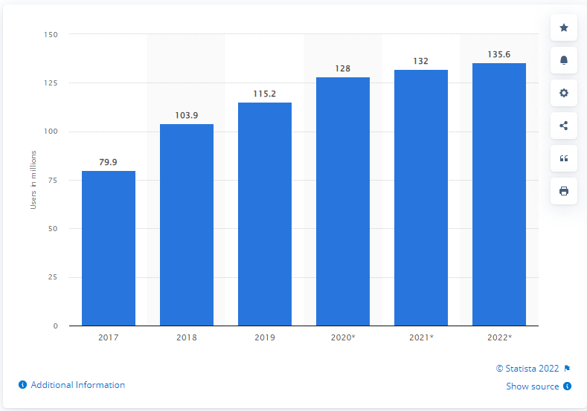

How many people in the US use voice assistants?

We estimate that 128.0 million people in the US will use a voice assistant at least monthly in 2020, up 11.1% from 115.2 million in 2019. This represents 44.2% of internet users and 38.5% of the total population. [12]

Figure 1 Number of voice assistant users in US

This voice assistant project offer a very specific feature set. I named the voice assistant Finansis. The main problem that Finansis application tries to solve is to help people to have financial freedom, to create a passive income for them. There are 9 main modules in this voice-controlled application User management, Stock Market News, Stock information, Speech recognition ,controlling the app with a voice, Speech synthesis, asking questions about the stock market, back-testing stock trading strategy, and automating stock trading. there are 59 commands that Finansis understand plus stock related questions (for example 'what is market capitalization’) and Finansis can ask more than 14 yes/no questions and then respond and do something based on a user's answer and lastly, Finansis can ask a user to choose stock from a list of stocks. Finansis has the ability to 'learn' about related Stock market questions and Stocks' symbol, actually Finansis just search in DuckduckGo (search engine like google) and then save the piece of information in the database. two mini-projects help Finansis news API, and Trading API, Trading API is a private project, news API is an API to save scraped news in the database and let Finansis retrieve news from the database and news API is online[13] There are four python scraping scripts running for 24 hours online, scraping news from yahoo finance, google finance, investing and seeking websites, and all that for free.

(scripts url: [14])

## System Development Environment Description

In software, web and mobile application development, the development environment is a workspace with a set of processes and programming tools used to develop the source code for an application or software product. The environments are categorized into groups, including frontend, backend, browser, IDE, Scraping, Automation, operating system, and programming language.

* programming language
  + JavaScript ES6
  + Python 3.8.2
* operating system
  + Windows 10 Version 21H2 (Build 19044.1645)
* Browser
  + Google Chrome 101.0.4951.54 (Official Build) (64-bit) (cohort: Stable)
* IDE
  + Visual Studio Code@1.66.2
* Front-end
  + React@17.0.2
  + Styled-components@5.3.3
  + react-speech-recognition@3.9.0 (Web Speech API)
  + Axios@0.24.0
  + Redux@4.1.2
  + material-ui@4.10.1
* Back-end
  + Axios@0.24.0
  + bcrypt @5.0.1
  + Cors@2.8.5
  + Crypto@1.0.1
  + Dotenv @10.0.0
  + Express@4.17.1
  + Jsonwebtoken@0.2.0
  + Mongoose@6.1.1
  + MongoDB
* Scraping
  + Replit
  + Webbot@0.34
  + BeautifulSoup@4.10.0
* Automation
  + Puppeteer@13.0.0

# Literature review

## Speech recognition

Speech recognition, or speech-to-text, is the ability of a machine or [program](https://www.techtarget.com/searchsoftwarequality/definition/program) to identify words spoken aloud and convert them into readable text. Speech recognition works by breaking down the audio of a speech recording into individual sounds, analyzing each sound, using algorithms to find the most probable word fit in that language, and transcribing those sounds into text [2]. Speech recognition uses natural language processing (NLP) and deep learning neural networks.

## NLP

NLP algorithms are typically based on machine learning algorithms. Instead of hand-coding large sets of rules, NLP can rely on machine learning to automatically learn these rules by analyzing a set of examples (i.e. a large corpus, like a book, down to a collection of sentences), and making a statistical conclusion. In general, the more data analyzed, the more accurate the model will be[3].

## Speech synthesis

Speech synthesis is the computer-generated simulation of human speech. It is used to translate written information into aural information.

How does Speech Synthesis Work? There are 3 stages in which speech synthesis works; text to words, words to phonemes, and phonemes to sound:

* Text to words

The initial stage of speech synthesis, is generally called pre-processing or normalization, it is everything about reducing ambiguity: it’s about narrowing down the many different ways a person could read a piece of text into the one that’s the most appropriate.

* Words to phonemes

Phonemes are one of the smallest units of speech that make one word different from another word. Once they figure out the words that need to be spoken, next the speech synthesizer has to generate the speech sounds that make up these words. Every computer needs is a huge alphabetical list of words and details of how to pronounce each word. For each word, they would need a list of the phonemes that make up its sound.

* Phonemes to sound

At this point, the computer has converted the text into a list of phonemes. But how to find basic phonemes that the computer reads aloud when it’s turning the text into speech. There are three different approaches to this.

* First to use recordings of humans saying the phonemes
* The second is for the computer to generate the phonemes itself by generating basic sound frequencies
* The last approach is to imitate the technique of the human voice

## Algorithmic Trading

Algorithmic trading is a method of executing orders using automated pre-programmed trading instructions accounting for variables such as time, price, and volume. This type of trading attempts to leverage the speed and computational resources of computers relative to human traders [7].

# Technologies Used To Create Voice Assistant

## Background info and pre-requisites

The following few points are designed to get you started with developing rapidly and easily a voice assistant.

### Introduction of NodeJS

NodeJS is an open-source, cross-platform runtime environment for developing server-side web applications. NodeJS also has an event-driven architecture capable of asynchronous I/O.

### Installation of NodeJS and NPM

Installation of NodeJS and NPM is straightforward using the installer package available at NodeJS official web site.

* Download the installer from NodeJS WebSite (https://nodejs.org/en/).

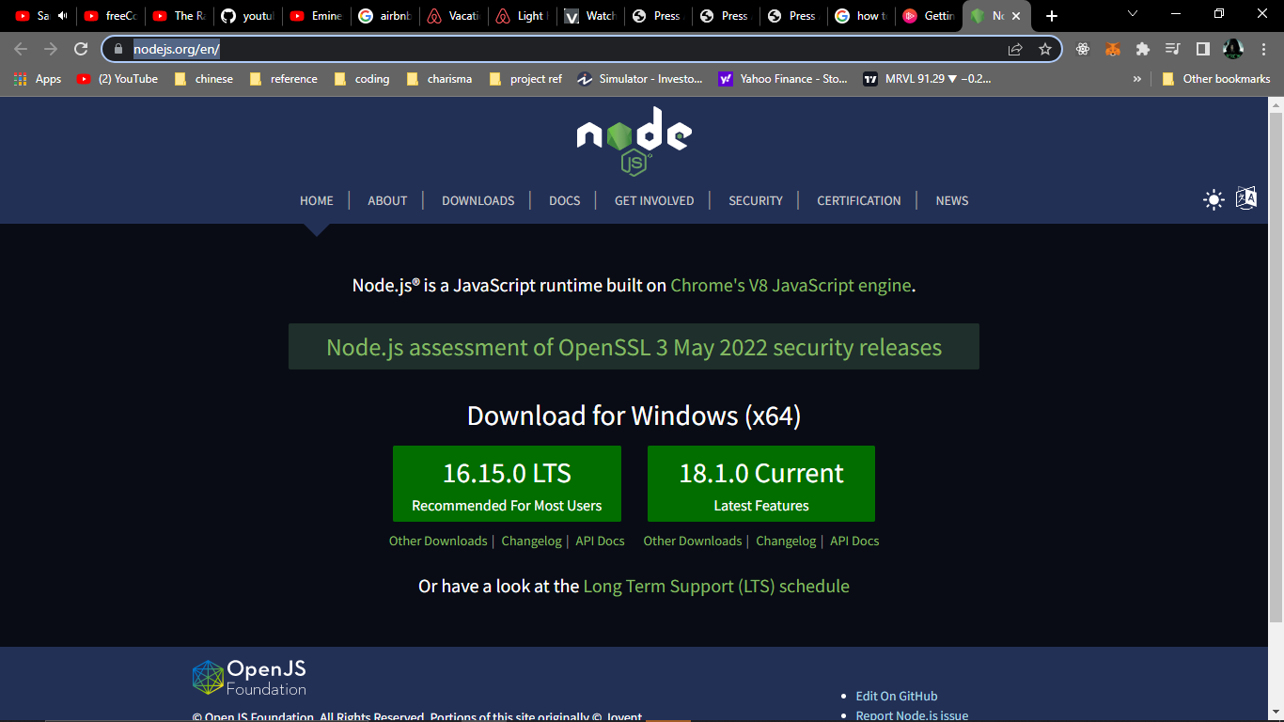

Figure 1 nodejs Website

* Run the installer.

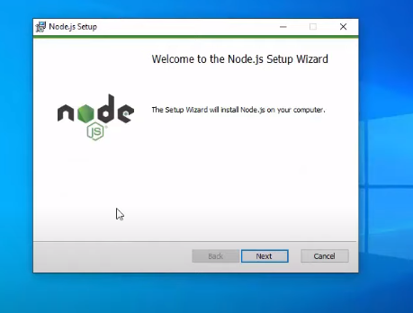

Figure 2 nodejs installer

* Follow the installer steps, agree the license agreement and click the next button

Now, let’s test NodeJS by printing its version using the following command in Command Prompt:

node -v

and test npm by printing its version using command

npm -v

### Introduction of ReactJS

React is a free and open-source front-end JavaScript library for building user interfaces based on UI components, We will use react to build our voice assistant because React makes it painless to create interactive UIs, and interactivity is important when it come to voice assistant.

### Creating ReactJS project using create-react-app

In this step, you’ll create a new application using the npm package manager to run a remote script. The script will copy the necessary files into a new directory and install all dependencies.

When you installed Node, you also installed a package managing application called npm.npm will install JavaScript packages in your project and also keep track of details about the project.

npm also includes a tool called npx, which will run executable packages. What that means is you will run the Create React App code without first downloading the project.

The executable package will run the installation of create-react-app into the directory that you specify. It will start by making a new project in a directory, which in this tutorial will be called simple-voice-assistant. Again, this directory does not need to exist beforehand; the executable package will create it for you. The script will also run ‘npm install’ inside the project directory, which will download any additional dependencies

To install the base project, run the following command:

npx create-react-app simple-voice-assistant

If you see the following message then you created react app successfully:

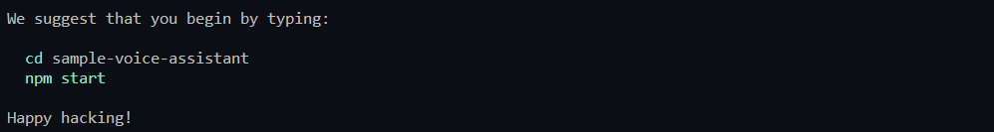

Now open the project with your favorite IDE, I will use VSCode

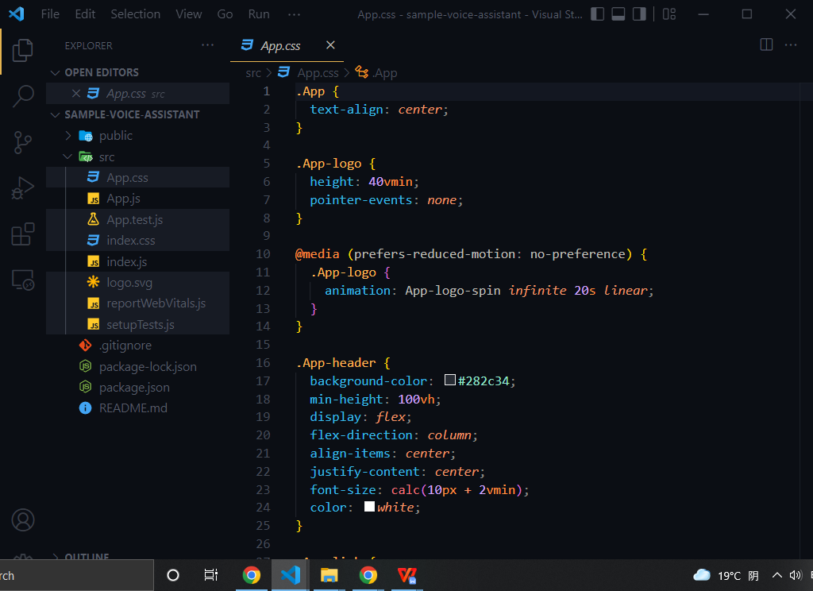

Figure 3

Remove all unnecessary files, only leave App.js and index.js, your folder should look like the following image:

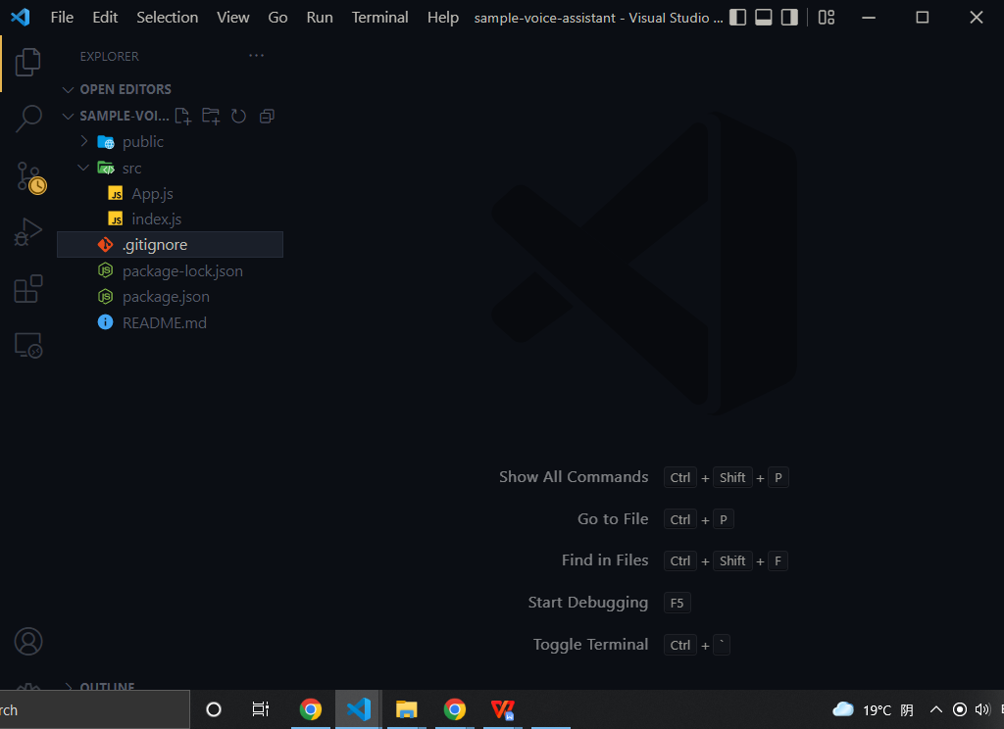

Figure 4

update App.js file like the following code:

function App() {

  return <div>simple voice assistant</div>;

}

export default App;

Update index.js file like the following code:

import React from "react";

import ReactDOM from "react-dom/client";

import App from "./App";

const root = ReactDOM.createRoot(

  document.getElementById("root")

);

root.render(

  <React.StrictMode>

    <App />

  </React.StrictMode>

);

Now run the following command to start react app in your localhost:8000:

npm start

If you see the following message in your command line you ran react project successfully:

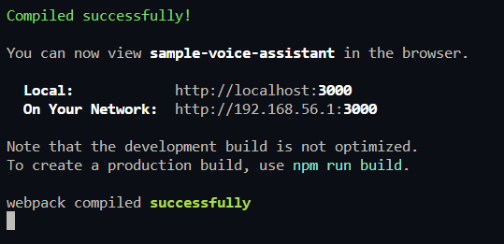

Figure 5

Let’s check out our project in the browser:

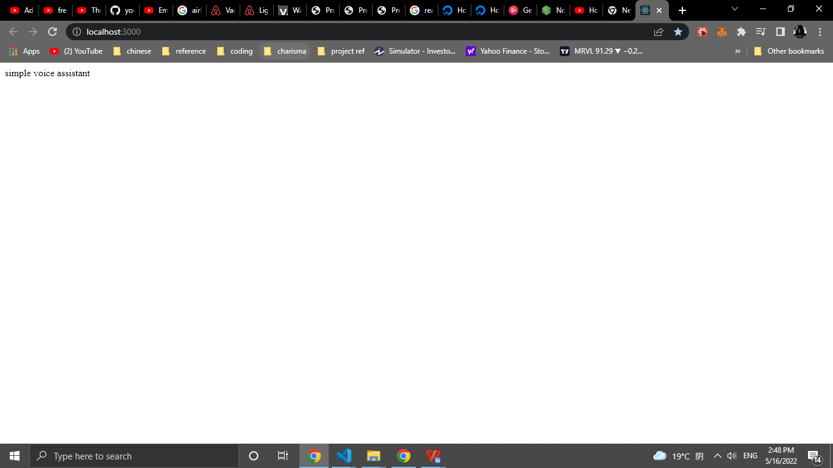

### Introduction of react-speech-recognition

A React hook that converts speech from the microphone to text and makes it available to your React components.

Under the hood, it uses Web Speech API. Note that browser support for this API is currently limited, with Chrome having the best experience.

### Installation of react-speech-recognition

run the following command to install react-speech-recognition:

npm install react-speech-recognition

Let check out if we installed react-speech-recognition successfully by updating App.js like the following code:

import SpeechRecognition, {

  useSpeechRecognition,

} from "react-speech-recognition";

function App() {

  const {

    transcript,

    listening,

    resetTranscript,

    browserSupportsSpeechRecognition,

  } = useSpeechRecognition();

  if (!browserSupportsSpeechRecognition) {

    return (

      <span>Browser doesn't support speech recognition.</span>

    );

  }

  const commonStyle = {

    display: "flex",

    justifyContent: "center",

    alignItems: "center",

    gap: "10px",

  };

  return (

    <div

      style={{

        ...commonStyle,

        flexDirection: "column",

        height: "100vh",

      }}

    >

      <p>Microphone: {listening ? "on" : "off"}</p>

      <div

        style={{

          ...commonStyle,

        }}

      >

        <button onClick={SpeechRecognition.startListening}>

          Start

        </button>

        <button onClick={SpeechRecognition.stopListening}>

          Stop

        </button>

        <button onClick={resetTranscript}>Reset</button>

      </div>

      <p>{transcript}</p>

    </div>

  );

}

export default App;

Now if you click on Start button and then say ‘can you here me’ you should see something like the following image:

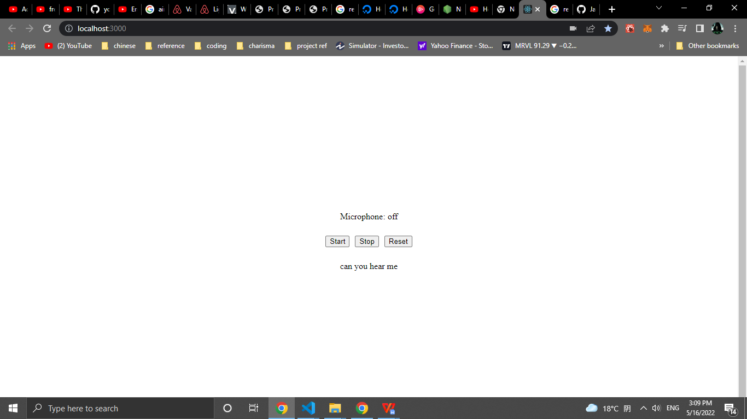

### Introduction of react-speech-kit

React hooks for in-browser Speech Recognition and Speech Synthesis. We only going to useSpeechSynthesis function from this package.

### Installation of react-speech-kit

Now run the following command to install react-speech-kit:

npm install react-speech-kit

If you had an error like me while installing react-speech-kit so go to <https://github.com/MikeyParton/react-speech-kit/blob/master/src/useSpeechSynthesis.jsx> and copy the code to your project like this:

1. Go to their GitHub

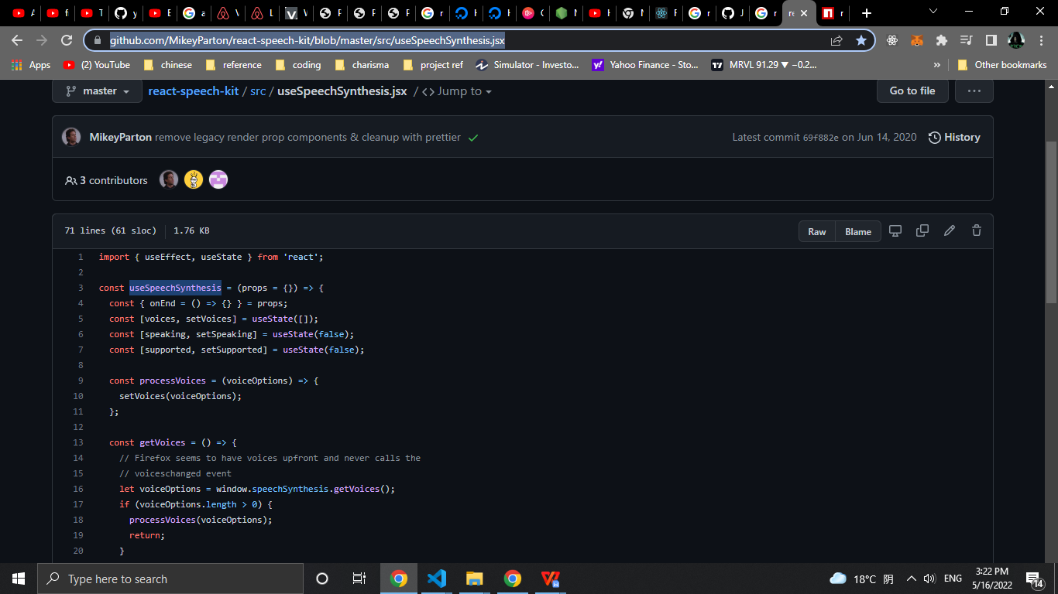

1. Click on copy button

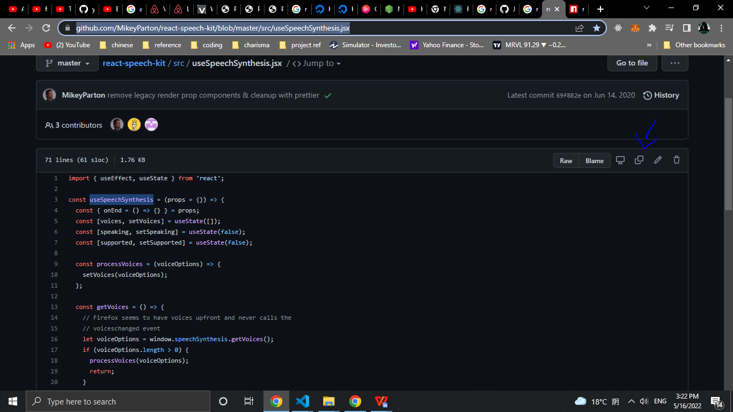

3 - create new file in your project called useSpeechSynthesis:

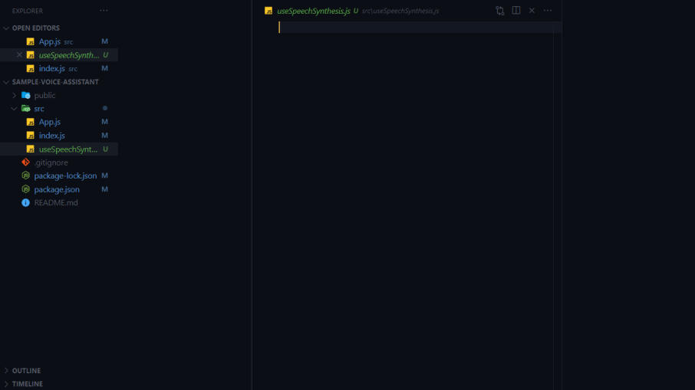

4 - pass their code in useSpeechSynthesis file:

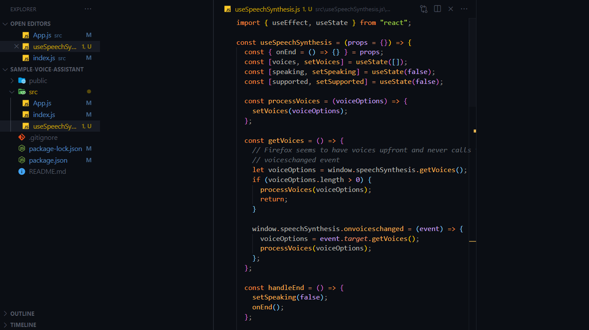

5 - import useSpeechSynthesis in App.js file:

import SpeechRecognition, {

  useSpeechRecognition,

} from "react-speech-recognition";

*// new code*

import useSpeechSynthesis from "./useSpeechSynthesis";

*// end of the new code*

function App() {

...

Let test useSpeachSynthesis now, we need to update App.js again, add the follow code:

*//start of new code*

import { useEffect } from "react";

*// end of the new code*

import SpeechRecognition, {

  useSpeechRecognition,

} from "react-speech-recognition";

import useSpeechSynthesis from "./useSpeechSynthesis";

function App() {

  const {

    transcript,

    listening,

*//start of new code*

    finalTranscript,

*// end of the new code*

    resetTranscript,

    browserSupportsSpeechRecognition,

  } = useSpeechRecognition();

*//start of new code*

  const { speak, voices } = useSpeechSynthesis();

  useEffect(() => {

    if (finalTranscript) {

      if (finalTranscript === "can you hear me") {

        speak({

          text: "yes, I can , and congratulations for your first voice assistant app",

          voice: voices[7],

        });

        console.log({ finalTranscript });

      } else {

        console.log("i don't understand");

        speak({

          text: "i don't understand",

          voice: voices[7],

        });

      }

    }

*// eslint-disable-next-line react-hooks/exhaustive-deps*

  }, [finalTranscript]);

*// end of the new code*

  if (!browserSupportsSpeechRecognition) {

    return (

      <span>Browser doesn't support speech recognition.</span>

    );

  }

. . .

Now if you click on Start button and then say ‘can you here me’ you should hear ‘yes, I can , and congratulations for your first voice assistant app’:

### Your first voice assistant

Let’s now add two more commands to change the background color by adding the following code in App.js:

*//start of new code*

import { useEffect, useState } from "react";

*// end of the new code*

*. . .*

. . .

  const { speak, voices } = useSpeechSynthesis();

*//start of new code*

  const [bgColor, setBgColor] = useState("white");

  const changeBGColor = (color) => {

    speak({

      text: `changing background to ${color}`,

      voice: voices[7],

    });

  };

*// end of the new code*

useEffect(() => {

    if (finalTranscript) {

      if (finalTranscript === "can you hear me") {

        speak({

          text: "yes, I can , and congratulations for your first voice assistant app",

          voice: voices[7],

        });

        console.log({ finalTranscript });

      }

*//start of new code*

      else if (

        finalTranscript === "change the background to red"

      ) {

        changeBGColor("red");

        setBgColor("red");

      } else if (

        finalTranscript === "change the background to White" ||

        finalTranscript === "change the background to white"

      ) {

        changeBGColor("white");

        setBgColor("white");

      }

*// end of the new code*

      else {

        console.log("i don't understand");

        speak({

          text: "i don't understand",

          voice: voices[7],

        });

      }

}

. . .

. . .

const commonStyle = {

    display: "flex",

    justifyContent: "center",

    alignItems: "center",

    gap: "10px",

  };

  return (

    <div

      style={{

        ...commonStyle,

        flexDirection: "column",

        height: "100vh",

*//start of new code*

        background: bgColor,

*// end of the new code*

      }}

    >

      <p>Microphone: {listening ? "on" : "off"}</p>

. . .

Now if you click on Start button and then say ‘change the background to red’ you should hear ‘changing background to red’ and the background should change to red like the following image:

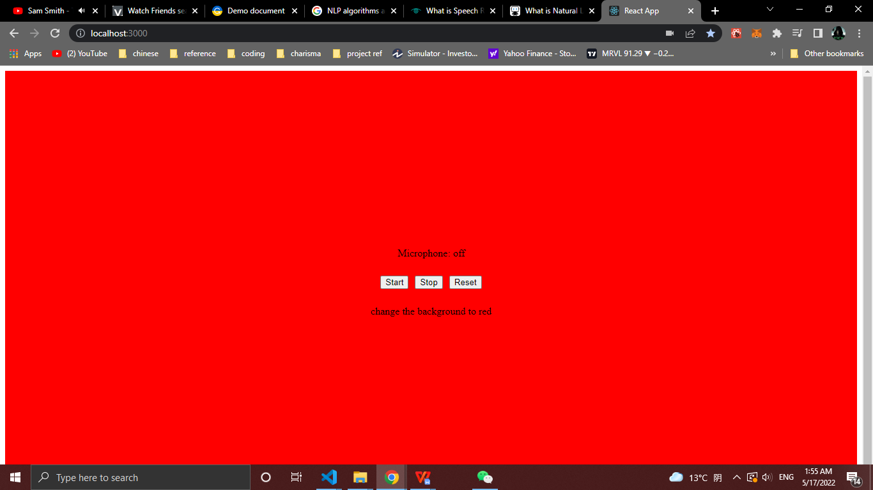

the full source code for this simple voice assistant in the following GitHub:

<https://github.com/nur1208/simple-voice-assistant>

### 

# REQUIREMENTS ANALYSIS

## Functional requirement

The modules involved are:

* + - User Management
    - Stock Market News
    - Stock Information
    - Speech recognition
    - Controlling the app with a voice
    - Speech synthesis
    - Asking questions about the stock market
    - Back-testing stock trading strategy
    - Automating stock trading  **(**Trading bot**)**

**User management** module contains all functionality related to users. a user can register to the app, can log in, can update his/her information, can update his/her password, can add and remove stocks from his/her watch list, and if a user forgets his/her password a user can create a new password by receiving a reset token in his/her email. the main function responsible for this module is useUserCommandsHandler in the source code

**The Stock Market News** module contains all functionality related to the news. getting news by source, keyword in the headline, latest or top stories. Get more news. scraping news from yahoo finance, google finance, investing, and seeking websites. saving scraped news in the database. letting Finansis start reading news headlines from the first article, start reading them from specific article's number, or stop reading them. opening article's details page with help of Finansis or without, if a window opened with Finansis’s help, Finansis can scroll the window. the main function is useNewsCommandsHandler.

**Stock information** module contains all functionality related to stock information. opening stock chart using yahoo finance's charts with Finansis's help or without, if the chart is opened with Finansis's help, Finansis can change the chart's typed daily, 1 minute, or whatever valid type, and Finansis can also zoom the chart in or out. opening multiple charts at once only without Finansis's help. Get the stock's current price (real-time price) for free using the following API (URL: https://yahoo-finance-api.vercel.app/AAPL). helping finansis to learn about companies. showing users the most active, gainers, or losers stocks by opening yahoo finance stocks screener. showing users a stock statistics by opening yahoo finance stock statistics section. showing users sold stocks by opening yahoo finance stock chart and then changing the date range to equal date of buying and selling of the sold stock.

**Speech recognition** module enable users to speak to Finansis and Finansis understand them, Speech Recognition module is the most important module in this project

**Controlling the app with a voice** module is to control the app by telling Finansis commands using Speech recognition module. navigating between pages by telling finansis 'go forward', 'go back' or 'go to {news|info|...} page' ({news|info|..} is dynamic values, for example: 'go to news page'). zooming in or out charts, scrolling news page, scrolling details news page. closing any popup window.

**Speech synthesis** module is to make Finansis speak out loud. responding to users, asking users yes/no questions, or asking users to choose a stock from a stock list. stopping Finansis from recognizing when Finansis start speaking out loud.

**Back-testing stock trading strategy** module is to let users test stock trading strategy of this application. users will input start date, end date, initial cash, and account risk per trade. helping developers of this app to come up with a better trading strategy. I will talk about back-testing later in this thesis.

**Asking questions about the stock market** module is to let users ask questions about the stock market and then Finansis answers the question, if the answer of the question not exist in the database, then Finansis will search in the DuckduckGo (search engine like Google) and after that save the answer in the database and lastly answer the question so if someone asked the same question again Finansis just answer it.

**Automating stock trading (Trading Bot)** module is to let Finansis buy, sell and set stop loss for stocks using Algorithmic Trading. the trading flow first set stop loss for bought stocks (I will talk about stop loss in the Algorithmic Trading section), second find sell signals for bought stocks and then sell them if a signal has been found, third scrap S&P 500 stocks (I will also talk about S&P 500 stocks in this thesis), and then save them in python array, fourth loop through all S&P 500 stocks to find buy signals then save them in the database if a signal has been found, lastly, get found buy signal stocks from the database and then buy them. in this project for current version 1.0 all buy and sell stocks in a simulator for the stock market I used Investopedia's simulator (URL: https://www.investopedia.com/simulator).

# SYSTEM DESIGN

Software design sits at the technical kernel of the software engineering process and is applied regardless of the development paradigm and area of application. Design is the first step in the development phase for any engineered product or system. The designer’s goal is to produce a model or representation of an entity that will later be built. Beginning, once system requirement has been specified and analyzed, system design is the first of the three technical activities - design, code and test that is required to build and verify software.

During design, progressive refinement of data structure, program structure, and procedural details are developed reviewed and documented. System design can be viewed from either technical or project management perspective. From the technical point of view, design is comprised of four activities – architectural design, data structure design, interface design and procedural design.

## System structure diagram

A System Structure Diagram is a type of UML Class Diagram. This model highlights the systems within a system. The following Diagram is Finansis’s Structure Diagram

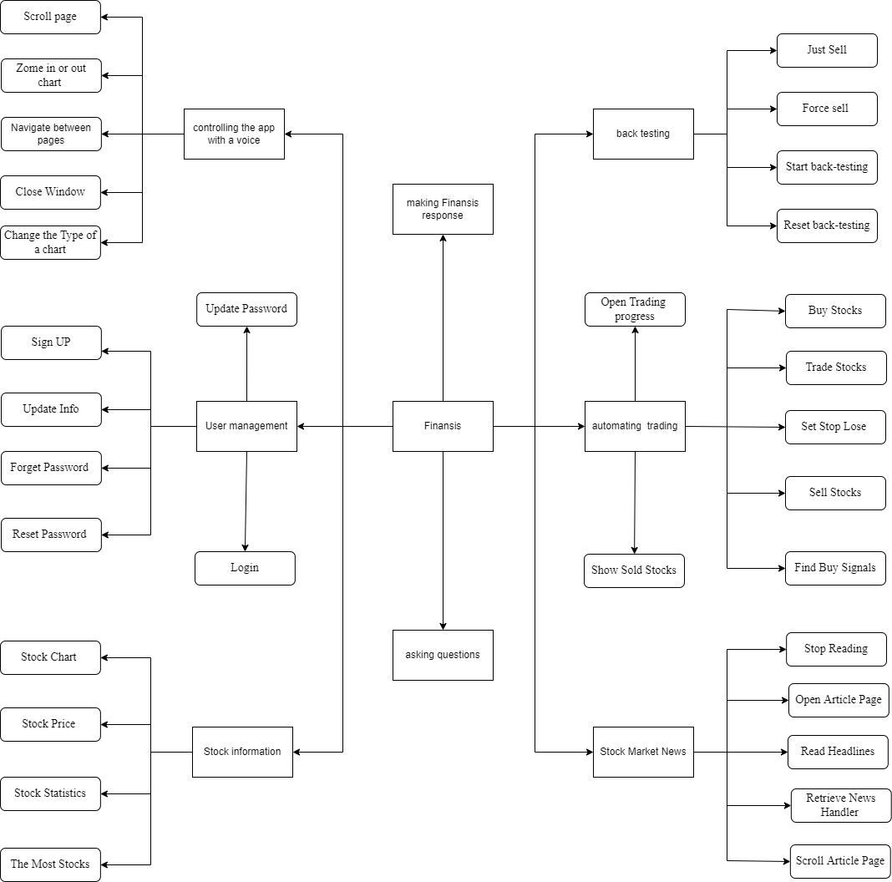

Figure 6 System structure diagram

## Data flow graph

### The first data flow graph

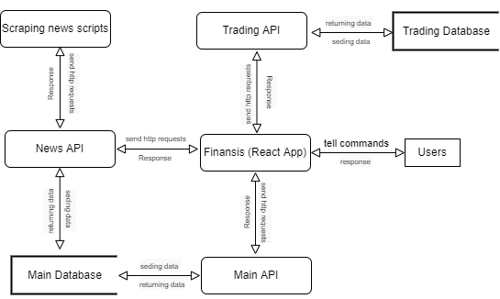

Figure 7 DFD-1

### The second data flow graph

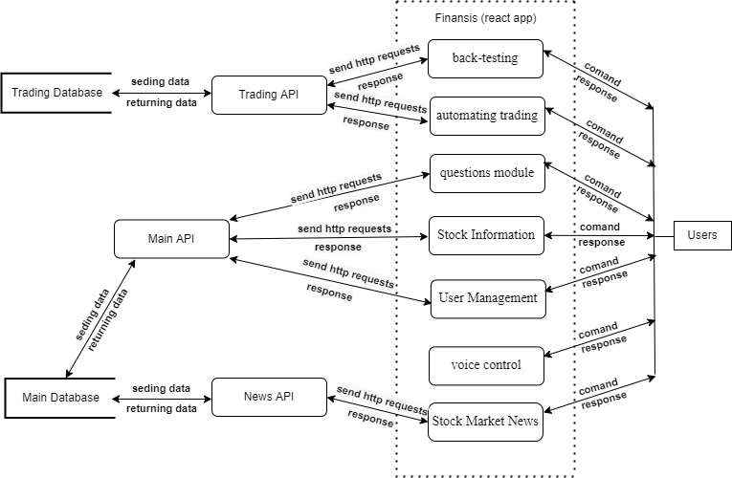

Figure 8 DFD-2FD-2

### The third data flow graph

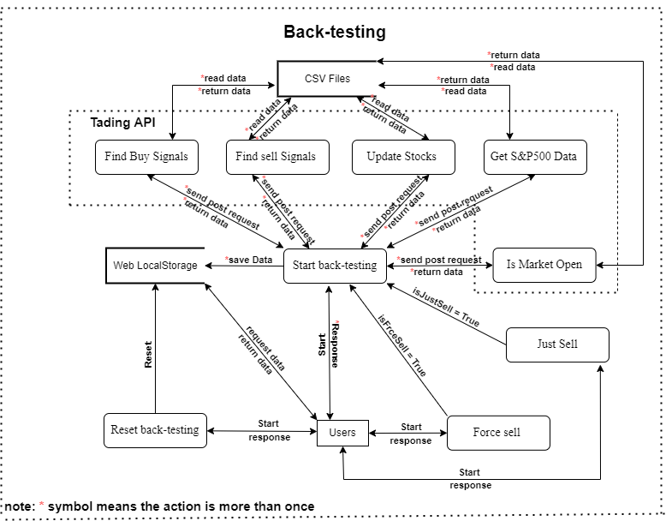

Figure 9 DFD (Back-Testing)-3-1

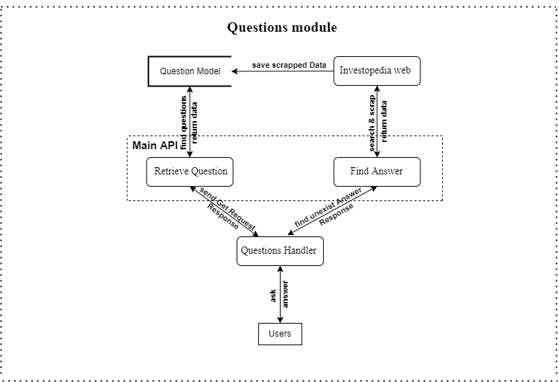

Figure 10 DFD (Questions)-3-2

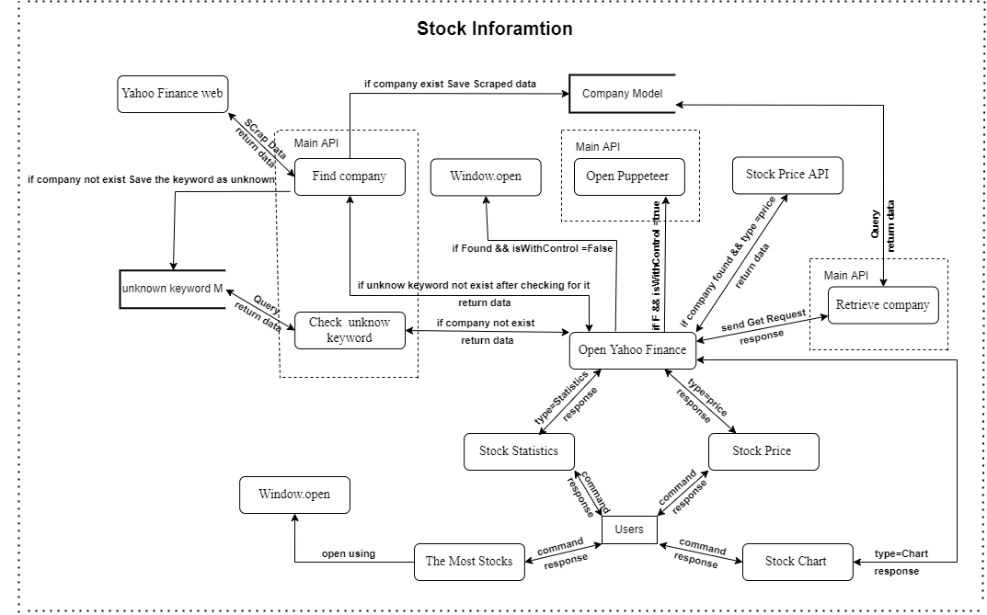

Figure 11 DFD (Stock Info)-3-3

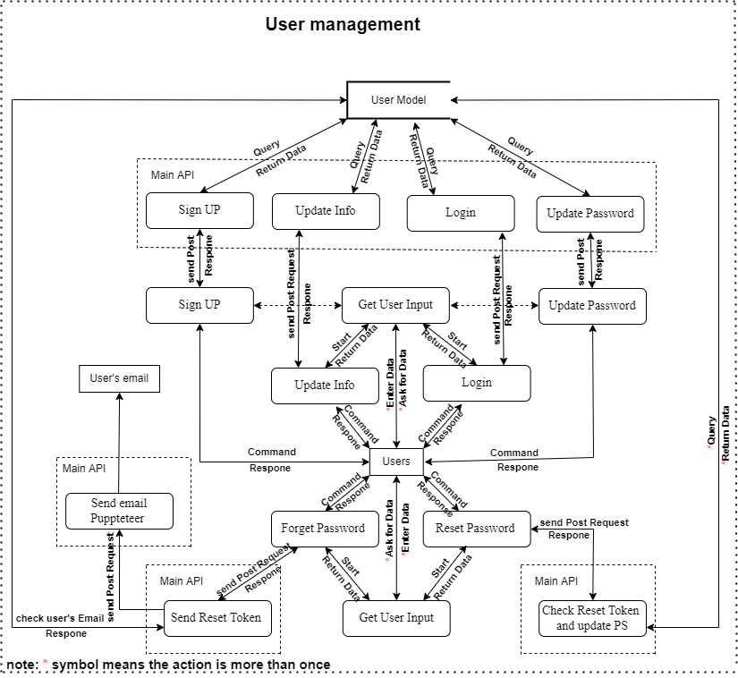

Figure 12 DFD (User Management)-3-4

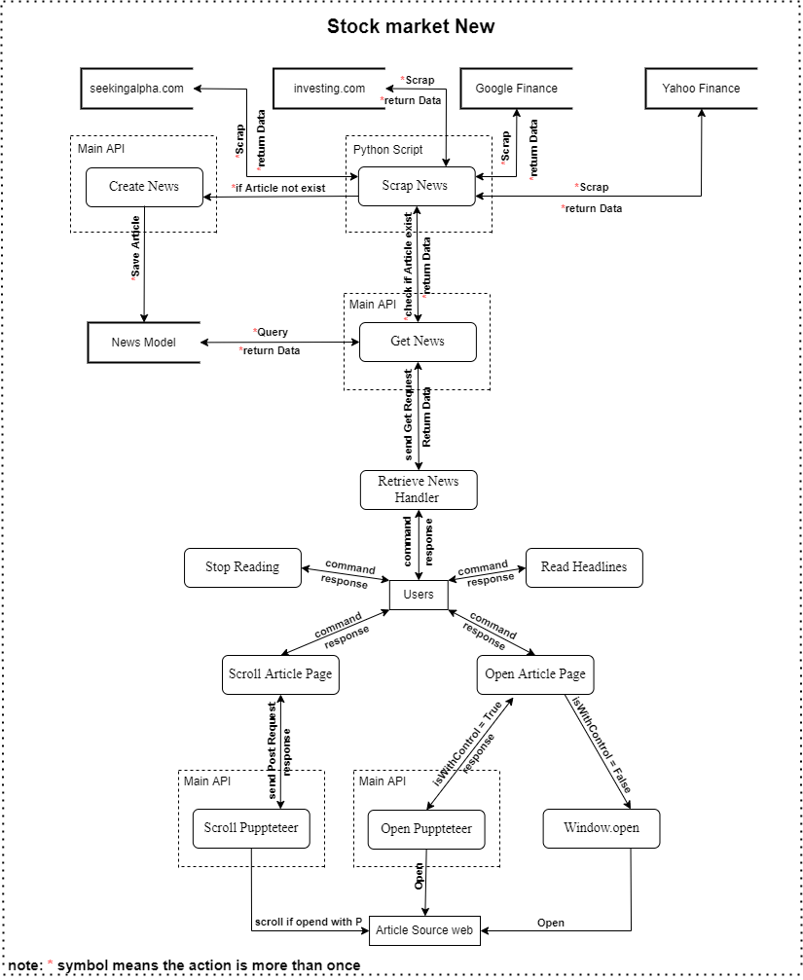

Figure 13 DFD (Stock Market News)-3-5

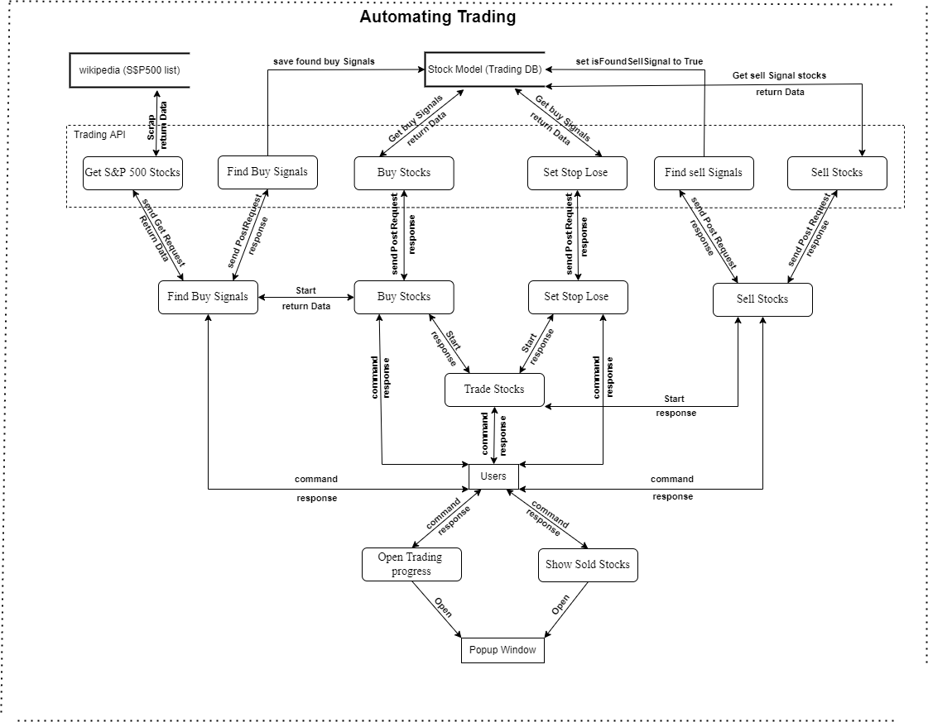

Figure 14 DFD (automating trading)-3-6

## Commands description:

note:

- if a word between () that means the word is optional.

- if a word between {} that means the word is dynamic.

- | is separator between the dynamic options for a command.

- ... means that there is more dynamic options then words inside {}.

### User management commands (10):

* sign up
* login
* forgot (my) password
* update my information
* logout
* update (my) password
* add {Apple|AAPL|...} stock to (my) watch list
* delete {Apple|AAPL|...} stock from (my) watch list
* open (my) watch list

### Stock Market News commands (10):

* Give me the news from {yahoo finance|investing|seekingalpha}
* open article (number) {1|5|...}
* what's up with {Apple|China|...}
* Give me the latest news
* read the news
* give me more news
* start reading (news) from article {1|5|...}
* open article (number) {1|5|...} without control
* give me top stories
* give me {Apple|AAPL|...} stock news

### Stock information commands (9):

* open {Apple|AAPL|...} (symbol) chart
* give me {Apple|AAPL|...} statistics
* give me The most {actives|gainers|losers} stocks
* give me trending stocks
* open {Apple|AAPL|...} (symbol) chart with your control
* what is the current price for {Apple|AAPL|...} (symbol)
* show me {Apple and Tesla|AAPL and DD|Apple and Tesla and amazon|...} charts

### controlling the app with a voice commands (5):

* go back
* go to {info|news|...} (page)
* close the window
* zoom {in|out}
* change the chart to {1 minute|1 hour|...}

### asking questions about the stock market commands:

* open details page for the answer
* what is market capitalization
* other questions exist in the database
* and any unknown command start with 'how' or 'what'

### back-testing stock trading strategy commands (4):

* start back testing
* reset back testing (data)
* force sell
* sell with profit or without

### other commands (10):

* stock (number) {1|5|...}
* what can you do
* what is your name
* (of course) yes
* no
* do you have a boyfriend
* can you hear me
* stop listening
* thank you
* what's the date today

### automating stock trading commands (8):

* buy stocks
* sell stocks
* set stop-loss for stocks
* trade stocks for me
* find buy signals
* show me (a) chart for found buy signals (stocks)
* sold stocks chart
* show me trading progress
* User management:

|  |  |
| --- | --- |
| command | sign up |
| input | user commands 'sign up' and then enters name, email, password, confirm password, and gender |
| process | first, check if a user logged in or not, if a user is not logged in then second response 'enter your name' and open inputModal to let a user enter his/her name after a user finishes entering then the third step is to close inputModal and save the user's input, and the same process for email, password, confirm password, and gender fields but with different response messages. and then send the user's data to the sign-up endpoint in the main API, and then in the main API check the user's data if valid or not, if it is valid so create a new user in the database and then log in a user by sending JWT token and then tell a user 'signed up and logged in successfully', otherwise response with an error message. if a user is logged in so then response 'you are logged in and then ask 'do you want to log out and create a new account', if a user response with 'yes' so then do the above sign up process. |
| output | If the information all have been filled correctly, the information will be inserted in the user table. Otherwise, the system will return the error message. |

Table 1 Register

|  |  |
| --- | --- |
| Command | forgot (my) password |
| input | user commands 'forgot (my) password' and then enters email. |
| process | first, check if a user logged in or not, if a user is not logged in then second response 'enter your email' and open inputModal to let a user enter his/her email after a user finishes entering then the third step is to close inputModal and save the user's input, and then send the user's data to the 'forget password' endpoint in the main API, and then in the main API check if the user's data valid or not, if it is valid so send a reset token to a user's email using 'send email' puppeteer script, otherwise response with an error message. if a user is logged in so then response 'you are logged in' and then ask 'do you want to update your password', if a user response with 'yes' so then do the update password process. |
| output | send a reset token to a user's email if a user not logged in and entered a valid email, otherwise response with a error message |

Table 2 forgot (my) password

|  |  |
| --- | --- |
| Command | update my information |
| input | user commands 'update my information' and then enters new name or new gender or both. |
| process | first, check if a user logged in or not, if a user is logged in then second response 'if you want to update your name type your new name, then click enter' and open inputModal with current user's name to let a user update his/her name after a user finishes entering then the third step is to close inputModal and update the user's input, and the same process for gender and then send the user's data to the 'update user info' endpoint in the main API, and then in the main API update user info in the database, and then send update info. if a user is not logged in so then response 'you not logged in' and then ask 'do you want to login', if a user response with 'yes' so then start the login process. |
| output | update user info if a user logged in, otherwise response with a error message |

Table 3 update my information

* Stock Market News:

|  |  |
| --- | --- |
| Command | Give me the news from {yahoo finance|investing|seekingalpha} |
| input | user commands 'Give me the news from {yahoo finance}' a user can also use investing or seeking alpha as valid source inside {} |
| process | first, send Get HTTP request with 'source' query string to News API, and then check if the given source exists in the database, if it exists return 10 documents to the client and then finansis will show the articles to the user, otherwise return 404 code to the client and then finansis will tell the user 'sorry, I didn't find news from {source}'. |
| output | show a user news based on the source, if the source exists in the database otherwise respond with an error message |

Table 4 Give me the news from {yahoo finance|investing|seekingalpha}

|  |  |
| --- | --- |
| Command | open article (number) {1|5|...} |
| input | user commands 'open article (number) {1}'. a user can use another number if the number is in the range of existing articles in the client. if there are ten articles so then a user can choose from 1 to 10. |
| process | first, check if the user logged in, for this command a user must be logged in because this command needs to use the user's executable chrome path to open puppeteer, if the user not logged in stop this process and tell the user "you not logged in, you need to log in for this command". second, check if executableChromePath exist in the user's data, if it not exist so then tell a user "oh no, I don't have your chrome executable path" and then open InputModal lastly tell the user 'paste it here to let me control your browser' then save executableChromePath and stop this process. third, if all check points passed so then send POST HTTP request to auto API (auto API is part of main API) 'open endpoints'. fourth, in auto API open puppeteer if puppeteer opened successfully respond with 200 code (okay), otherwise 500 code (server error). |
| output | open details article page if all check points passed successfully otherwise respond with an error message. |

Table 5 Give me the news from {yahoo finance|investing|seekingalpha}

|  |  |
| --- | --- |
| Command | what's up with {Apple|China|...} |
| input | user commands 'what's up with {China}, a user can use any other keyword inside {}. |
| process | first, send Get HTTP request with 'keywordInTitle' query string to News API, and then search for the given keyword in articles' title, if found result for the search query so then return 10 documents to the client and then Finansis will show the articles to the user otherwise return 404 code to the client and then finansis will tell the user 'sorry, I didn't find news for {keyword} keyword'. |
| output | show a user news based on the given keyword, if searching for the keyword in articles' title returns articles otherwise respond with an error message |

Table 6 what's up with {Apple|China|...}

|  |  |
| --- | --- |
| Command | Give me the latest news |
| input | user commands 'Give me the latest news' |
| process | first, send Get HTTP request with 'sortBy=publishedAt' query string to News API and then return the most recent 10 documents and then finansis will show the articles to the user and if there is something wrong from News API return 500 code (server error) and then finansis will tell the user 'sorry, I didn't find any news'. |
| output | show a user recent news |

Table 7 Give me the latest news

|  |  |
| --- | --- |
| Command | give me more news |
| input | user commands 'give me more news' |
| process | add one to page variable then send Get HTTP request with 'page=2' string query plus mine string query to News API and then return 10 articles if there are more articles and then finansis will show the articles to the user otherwise return 404 code (didn't find results) to the client and then finansis will tell the user 'sorry, I didn't find any news' . |
| output | getting more articles |

Table 8 Give me more news

|  |  |
| --- | --- |
| Command | start reading (news) from article {1|5|...} |
| input | user commands 'start reading (news) from article {5}'. a user can use another number if the number is in the range of existing articles in the client. if there are ten articles so then a user can choose any number from 1 to 10. |
| process | first, check if a number is valid number  and then Finansis will start reading the news' headline from given number article (ex: 5) to the last article if there are article otherwise tell a user 'there is no news to read.'.  if a number is invalid number so tell a user `the article with number {num} not exist so I can't read it.` |
| output | Finansis starts reading the news' headline out loud starting from the given number. |

Table 9 start reading (news) from article {1|5|...}

|  |  |
| --- | --- |
| Command | open article (number) {1|5|...} without control |
| input | user commands 'open article (number) {1} without control'. a user can use another number if the number is in the range of existing articles in the client. if there are ten articles so then a user can choose from 1 to 10. |
| process | first, check if a number is valid number, if it is a valid number open the article |
| output | opening an article page |

Table 10 open article (number) {1|5|...} without control

|  |  |
| --- | --- |
| Command | give me top stories |
| input | user commands 'give me top stories'. |
| process | first, send Get HTTP request with 'source=google finance' string query to News API and then return top 10 articles because google Finance only shows top stories from all the news websites by default  and then finansis will show the articles to the user and if there is something wrong from News API return 500 code (server error)  and then finansis will tell the user the error message |
| output | showing top news articles |

Table 11 give me top stories

|  |  |
| --- | --- |
| Command | give me {Apple|AAPL|...} stock news |
| input | user commands 'give me {Apple} stock news'. a user can use a company name or it's stock symbol inside {} |
| process | first, check if a user said a stock's symbol, a company name, or an unknown keyword,  if the input is a stock symbol or company name and it is in the database so then open yahoo finances website using `${YAHOO_FINANCE_URL}/quote/${symbol}?p=${symbol}` url.  if the input is a stock symbol or company name and it is not in the database so then search the keyword in yahoo finance and then scrap the data if even didn't find any result after scraping so then save the keyword in the database as unknown keyword |
| output | opening yahoo finance website news section with a given stock |

Table 12 logout

* Stock information:

|  |  |
| --- | --- |
| Command | open {Apple|AAPL|...} (symbol) chart |
| input | user commands 'open {Apple} (symbol) chart'. a user can use a company name or it's stock symbol inside {} |
| process | first, check if a user said a stock's symbol, a company name, or an unknown keyword, if the input is a stock symbol or company name and it is in the database so then open yahoo finances website using `${YAHOO_FINANCE_URL}/chart/${symbol}` url, otherwise it is not in the database so then search the keyword in yahoo finance and then scrap the data if even didn't find any result after scraping so then save the keyword in the database as unknown keyword |
| output | opening yahoo finance website chart section with a given stock |

Table 13 open {Apple|AAPL|...} (symbol) chart

|  |  |
| --- | --- |
| Command | give me {Apple|AAPL|...} statistics |
| input | user commands 'give me {Apple} statistics'. a user can use a company name or it's stock symbol inside {} |
| process | first, check if a user said a stock's symbol, a company name, or an unknown keyword,  if the input is a stock symbol or company name and it is in the database so then open yahoo finances website using `${YAHOO_FINANCE_URL}/quote/${symbol}/key-statistics?p=${symbol}` url.  otherwise it is not in the database so then search the keyword in yahoo finance and then scrap the data if even didn't find any result after scraping so then save the keyword in the database as unknown keyword |
| output | opening yahoo finance website statistics section with a given stock |

Table 14 give me {Apple|AAPL|...} statistics

|  |  |
| --- | --- |
| Command | give me The most {actives|gainers|losers} stocks |
| input | user commands 'give me The most {actives} stocks'. a user can also use gainers or losers inside {} |
| process | first, check if a user said a valid input, if it is open yahoo finances website using `${YAHOO_FINANCE_URL}/most-active` url for the most active stocks, using `${YAHOO_FINANCE_URL}/gainers` url for the most gainers stocks and using `${YAHOO_FINANCE_URL}/losers` url for the most losers stocks. |
| output | opening yahoo finance website the most stocks section with a given keyword |

Table 15 give me The most {actives|gainers|losers} stocks

|  |  |
| --- | --- |
| Command | give me trending stocks |
| input | user commands 'give me trending stocks'. |
| process | open yahoo finances website using `${YAHOO_FINANCE_URL}/trending-tickers` url. |
| output | opening yahoo finance website trending stocks section |

Table 16 give me trending stocks

|  |  |
| --- | --- |
| Command | open {Apple|AAPL|...} (symbol) chart with your control |
| input | user commands 'open {Apple} (symbol) chart with your control'. a user can use a company name or it's stock symbol inside {} |
| process | first, check if a user said a valid stock symbol or name, if a user said invalid stock symbol or name and didn't find result after scraping stop this process. second, check if the user logged in, for this command a user must be logged in because this command needs to use the user's executable chrome path to open puppeteer, if the user not logged in stop this process and tell the user "you not logged in, you need to log in for this command". third, check if executableChromePath exist in the user's data, if it not exist so then tell a user "oh no, I don't have your chrome executable path" and then open InputModal lastly tell the user 'paste it here to let me control your browser' then save executableChromePath and stop this process fourth, if all check points passed so then send POST HTTP request to auto API (auto API is part of main API) 'open endpoints'. fifth, in auto API open puppeteer if puppeteer opened successfully respond with 200 code (okay) and open the chart, otherwise 500 code (server error). |
| output | logout a user if a user logged in, otherwise response with a error message |

Table 17 open {Apple|AAPL|...} (symbol) chart with your control

|  |  |
| --- | --- |
| Command | what is the current price for {Apple|AAPL|...} (symbol) |
| input | user commands 'what is the current price for {Apple} (symbol)'. a user can use a company name or it's stock symbol inside {} |
| process | first, check if a user said a valid stock symbol or name, if a user said invalid stock symbol or name and didn't find result after scraping stop this process. otherwise, send http request to Stock Price API then let finansis tell and show it to the user. |
| output | real-time stock price |

Table 18 what is the current price for {Apple|AAPL|...} (symbol)

|  |  |
| --- | --- |
| Command | show me {Apple and Tesla|AAPL and DD|Apple and Tesla and amazon|...} charts |
| input | user commands 'show me {Apple and Tesla} charts'. a user can use any two, three or more stocks split by 'and' word inside {}. for example 'show me {AAPL and Tesla and amazon} charts'. |
| process | first, check if all the stocks that the user said a valid stock symbol or name, if a user said invalid stock symbol or name and didn't find result after scraping stop this process. otherwise, open a window for each stock a user said. |
| output | opening multiple charts |

Table 19 show me {Apple and Tesla} charts

* controlling the app with a voice commands:

|  |  |
| --- | --- |
| Command | go back |
| input | user commands 'go back'. |
| process | first, check if there is element in the custom historyStack, if the condition true so then go back and pop the element from historyStack and then push it to forwardStack. if the condition false so then tell a user 'there is nothing back'. |
| output | navigating back |

Table 20 go back

|  |  |
| --- | --- |
| Command | go to {info|news|...} (page) |
| input | user commands 'go to {info} (page)'. a user can also use back testing, trading , home or news inside {}. |
| process | first, check if a user in the same page, if the condition false tell the user 'you are in {info} page' and then stop this process. second, if the first condition true so then check if a user said a valid page, if the condition false so then tell the user '{nur} page is not exist' and then stop this process. if all conditions true so then navigate to the given page. |
| output | navigating to the given page |

Table 21 go to {info|news|...} (page)

|  |  |
| --- | --- |
| Command | close the window |
| input | user commands 'close the window'. |
| process | fcheck if there is a window opened, if the condition true so then close the window otherwise tell a user 'there is no window open to close it' |
| output | closing popup window |

Table 22 close the window

|  |  |
| --- | --- |
| Command | zoom {in|out} |
| input | user commands 'zoom {in}'. a user can also use 'out' inside {}. |
| process | first, check if a user said a valid zooming keyword, if the condition false so then stop this process and tell a user '{nur} is not valid option for zooming' second, check if a chart window using puppeteer is opened, if the condition false so then stop this process and tell a user 'chart window is close so I can not zoom {in}' third, if all the condition true then send http request to AUTO API to zoom in or out the chart . |
| output | zooming the chart |

Table 23 zoom {in|out}

|  |  |
| --- | --- |
| Command | change the chart to {1 minute|1 hour|...} |
| input | user commands 'change the chart to {1 minute}'. a user can also use '1 hour', '1 day', '1 week' , '1 year' or any other valid chart type inside {} |
| process | first check if a chart window using puppeteer is opened if the condition false so then tell a user 'browser with my control is closed so, I can't change the chart' and stop this process, second, check if a user said a valid chart type, if the condition false so then tell a user '{Nur} is not valid option' and stop this process, third, if all the condition true so then send http request to AUTO API to change the chart type. |
| output | changing chart type |

Table 24 change the chart to {1 minute|1 hour|...}

|  |  |
| --- | --- |
| Command | go forward |
| input | user commands 'go forward'. |
| process | first, check if there is element in the forwardStack, if the condition true so then go forward and pop the element from forwardStack and then push it to historyStack. if the condition false so then tell a user 'there is nothing forward'. |
| output | navigating forward |

Table 25 go forward

* Asking questions about the stock market commands:

|  |  |
| --- | --- |
| Command | what is market capitalization |
| input | user asks 'what is market capitalization'. a user can also ask any other question related to the stock market |
| process | first, check if there is answer for the question in the database, if the condition true so then answer the question,  if the condition false and question or the command starts with 'how' or 'what' so then ask a user "do you want me to find answer for 'what is nur'" if a user says yes so then search for an answer in investopedia website and then scrap the answer and save the answer in the database and lastly answer the user  if didn't find an answer after scraping so then tell a user 'didn't find answer for your question' |
| output | answering a users for their questions |

Table 26 what is market capitalization

* back-testing stock trading strategy commands:

|  |  |
| --- | --- |
| Command | start back testing |
| input | user commands 'start back testing' and then enters , initial cash, start date, account risk by trade and end date. |
| process | first, check if a user already has tested data in his local storage if the condition is true so then tell a user 'you already have tested data' and then ask a user 'do you want me to overwrite the old data if a user answers 'no' so then stop this process if a user answers 'yes' so then reset back-testing data that is in the user's local storage, after that tell a user 'enter initial cash then click enter to submit after the reloading' and reload the page after a user enters initial cash tell a user 'enter start date' and after entering let a user enters Account Risk and End Date then start back-testing by first send POST request to 'is market open' endpoint in Trading API and second, send a POST request to 'get 500 s&p index data' endpoint in Trading API third, send a POST request to 'update current stocks price' endpoint in Trading API, fourth, sending POST request to 'sell stocks Back-testing' endpoint in Trading API, fifth, send a POST request to 'buy stocks Back-testing' endpoint in Trading API and keep sending those requests one by one until the start date equals the end date. note if sending the request to 'get 500 s&p stocks' fails so send the request again after 10 seconds and only if the request has been sent successfully and then send a request to 'update current stocks price' endpoint and the same for each request.' |
| output | show a user the result for finansis's stock trading strategy |

Table 27 back-testing stock trading strategy commands

|  |  |
| --- | --- |
| Command | reset back testing (data) |
| input | user commands 'reset back testing (data)'. |
| process | reset back testing by clear the user's localStorage and reloading th page |
| output | reset back testing data |

Table 28 reset back testing (data)

|  |  |
| --- | --- |
| Command | force sell |
| input | user commands 'force sell'. |
| process | first, check if there is more data in the Trading API to test if the condition false so then tell a user 'sorry I don't have more data to test, right now' and then stop this process otherwise check if a user has stocks to sell in holdingStocks backTest array if the condition false so then tell a user 'you don't have any stocks to sell' otherwise start back testing process that mentioned above and add isForce=true flag to it so then send all the requests except 'buy stocks Back-testing' request |
| output | force sell (sell the stock without following sell strategy with any profit) |

Table 29 force sell

|  |  |
| --- | --- |
| Command | sell with profit or without |
| input | user commands 'sell with profit or without'. |
| process | first, check if there is more data in the Trading API to test if the condition false so then tell a user 'sorry I don't have more data to test, right now' and then stop this process otherwise check if a user has stocks to sell in holdingStocks backTest array if the condition false so then tell a user 'you don't have any stocks to sell' otherwise start back testing process that mentioned above and add isJustSell=true flag to it so then send all the requests except 'buy stocks Back-testing' request |
| output | start selling stocks with profit or without |

Table 30 sell with profit or without

* automating stock trading commands:

|  |  |
| --- | --- |
| Command | buy stocks |
| input | user commands 'buy stocks' |
| process | first, start 'finding buy signals' process that I will mention below,  if 'finding buy signals' process finished successfully and found buy signals for stocks so then send HTTP request to 'buy stocks' endpoint in Trading API and then open Investopedia's simulator using puppeteer to automate buying stocks and then save bought stocks in the database otherwise tell a user something went wrong while buying Stocks. |
| output | buying stocks using puppeteer automation functionality |

Table 31 buy stocks

|  |  |
| --- | --- |
| Command | sell stocks |
| input | user commands 'sell stocks' |
| process | first, finding sell signals for bought stocks, if there is an error tell a user 'something went wrong while checking for selling signals' and stop this process otherwise check if found stocks if didn't find any signals so then tell a user 'didn't find any sell signals today' and stop this process otherwise start the second step which is selling stock using puppeteer by sending an HTTP request to Trading API.  note if there were an error while doing this process Finansis will ask the user 'do you want me to try to {sell} again' if the answer is yes try selling again. |
| output | finding sell signals and selling stocks using puppeteer automation functionality |

Table 32 sell stocks

|  |  |
| --- | --- |
| Command | set stop-loss for stocks |
| input | user commands 'set stop-loss for stocks' |
| process | send an HTTP request to trading API's 'set stop loss' endpoint and open Investopedia's simulator using puppeteer to automate setting a stop loss for stocks if there were an error so then tell a user 'something went wrong while buying stop loss' or if didn't find any stocks to set stop loss to them so tell a user "didn't found stocks to set stop loss to them". |
| output | setting stop loss for stocks using puppeteer automation functionality |

Table 33 set stop-loss for stocks

|  |  |
| --- | --- |
| Command | find buy signals |
| input | user commands 'find buy signals' |
| process | first, send an HTTP request to Trading API's 'get S&P 500 stocks' endpoint to scrap s&p 500 stocks and save them, if there were an error so tell a user 'something went wrong while saving S&P 500 stocks' otherwise, send an HTTP request to Trading API's 'find buy signals' endpoint to find buy signals and then save them in the database if there were an error so tell a user 'something went wrong while looking for buy signals' and if didn't find any buy signal so tell a user 'didn't find any buy signal' |
| output | scraping s&p 500 stocks and finding buy signals |

Table 34 find buy signals

|  |  |
| --- | --- |
| Command | trade stocks for me |
| input | user commands 'trade stocks for me' |
| process | first, start the above 'set stop loss' process, second, start the above 'sell stocks' process, lastly, start the above 'buy stocks' process. |
| output | start all trading processes |

Table 35 trade stocks for me

|  |  |
| --- | --- |
| Command | show me (a) chart for found buy signals (stocks) |
| input | user commands 'show me (a) chart for found buy signals (stocks)' |
| process | opening all stocks that found buy signal for them using the above 'opening multiple chart' process |
| output | opening charts for stock that found buy signal for them |

Table 36 show me (a) chart for found buy signals (stocks)

|  |  |
| --- | --- |
| Command | sold stocks chart |
| input | user commands 'sold stocks chart' |
| process | first, check if the user logged in, for this command a user must be logged in because this command needs to use the user's executable chrome path to open puppeteer, if the user is not logged in so then stop this process and tell the user "you not logged in, you need to log in for this command". second, let a user choose one of the sold stocks by telling him 'the following stocks have been sold choose one by saying stock number 3 for example' third, check if executableChromePath exists in the user's data, if it not exist so then tell a user "oh no, I don't have your chrome executable path" and then open InputModal lastly tell the user 'paste it here to let me control your browser' then save executableChromePath and stop this process fourth, if all checkpoints passed so then send a POST HTTP request to auto API (auto API is part of the main API) 'open endpoints'. fifth, in auto API open puppeteer, if puppeteer opened successfully respond with 200 code (okay) and open the chart, otherwise 500 code (server error). lastly, send an HTTP request to Trading API's 'change chart date' endpoint to adjust the start date and end date of the chart. |
| output | opening charts for stock that found buy signal for them |

Table 37 show me (a) chart for found buy signals (stocks)

|  |  |
| --- | --- |
| Command | show me trading progress |
| input | user commands 'show me trading progress' |
| process | tell a user 'here is your trading progress' and then open Progress Modal and then after 10 seconds close the modal |
| output | opening Progress Modal |

Table 38 show me trading progress

# SYSTEM PROBLEMS

In this section I will talk about major problem occurred while building this Project and how I solved them:

* **Let Finansis recognizes English words:** solved by using react-speech-recognition npm package which uses Web Speech API.
* **Let Finansis speaks out loud:** solved by copying react-speech-kit npm package's 'useSpeechSynthesis' function and then adding more logic to the function. useSpeechSynthesis function uses Web Speech API too.
* **Run scraping news script for 24 hours**: solved by using python's webbot and Beautiful Soup packages to write scraping news scripts and Replit online IDE to run the scrips for 24 hours and also using python's request package to call news API's 'save articles' endpoint.
* **Let Finansis recognizes unknown commands**: solved by creating some logic to check for the user's command against existing commands, you can find the logic in the source code appUtils file under 'code for handling unknown commands' comment.
* **Deploy new's api**: solved by using verce.
* **Open yahoo finance website with different stocks (with dynamic value)**: solved by finding a pattern in yahoo finance' URL which is passing the stock symbol in ‘${dynamic value}’ https://finance.yahoo.com/quote/${dynamic value}?p=${dynamic value}.
* **Get real-time stock prices**: solved by finding free API to provide real-time stock prices (API URL: https://yahoo-finance-api.vercel.app/${symbol}), (youtube https://www.youtube.com/watch?v=JVZXz6awRj4&t=3573s).
* **Let Finansis calls puppeteer scripts (automation scrips)**: solved by creating auto API using node js express which is each endpoint will call specific automation script, and then using Axios to let Finansis calls the API. note: I tried to call puppeteer scripts in react which is Client-side rendering but didn't work because puppeteer scripts only run in Server-side rendering.
* **Let Finansis control the popup window that Finansis opened**: solved by using puppeteer automation functionality and then doing the same as the above problem's solution.
* **Let Finansis calls python scripts (Algorithmic Trading scripts)**: solved by creating API using python Flask each endpoint will call specific python script, and then using Axios to let Finansis calls Flask API.
* **Let the user enter info field by field and finansis keep interacting with the user**: solved by creating 'InputModal' modal which will open when the time to enter information and after a user finishes inputting then entering 'Enter' and then close the modal and save entered data in redux, lastly let finansis response when a data in redux changes.
* **Send emails to users**: solved by creating endpoint in auto API which will call puppeteer automation script to send emails to a user. note: I tried to use nodemailer but it didn't work without a VPN
* **Create back-testing interface**: solved by cloning Investopedia simulator home page and then customizing it.
* **Create back-testing functionality**: solved by creating python Flask buy, sell, get sp500 Data, update stocks price and check is market open or not endpoints and then using them in React.
* **Manage state in big application**: solved by using redux which is react state management
* **get the real stocks in the s&p 500 for a specific year in backTesting functionality**: this problem has been not solved yet.
* **Let finansis learn about stock market questions:** solved by searching for an answer in DuckduckGo search engine using puppeteer to type the question, select the first website, scrap the answer and then save the answer in the database. actually, if the question was 'what is market capitalization' finansis will search about the question and add 'investopedia' word at the end of the question for example 'what is market capitalization investopedia' so then the first result will be from investopedia website and that because investopedia is a good website for finding stock market answers
* **Let Finansis learn about stocks symbol and their company name**: solved by searching for stock in yahoo finance database using puppeteer to type the stock in yahoo finance search bar, select all suggested stocks, scrap the stocks and then save them in the database.
* **Let Finansis remember an unknown keyword in yahoo finance database for stocks**: solved by creating 'unknownKeywordForCompany' model, if Finansis search for a keyword in yahoo finance search bar, but didn't find any stock with the given keyword so then finansis will save the given keyword in the database, for example searching 'Nur' keyword will return nothing, so next time when searching for 'Nur' keyword it will take short time for Finansis to tell a user 'didn't find a stock with the given keyword', let Finansis remember that 'Nur' keyword returns nothing so no need for searching 'Nur' again.
* **Not having duplicate news article in the database**: solved by making the article's title plus published date plus source a unique value for each article, so when the article has been scrapped, first the script will make get request to the news API by passing the unique value if the article exists then no need to save it again, otherwise send a post request to news API to save the article.
* **not let Finansis recognize her own voice**: solved by stopping Finansis from recognizing when Finansis start to speak out loud then after finishing speaking making Finansis start recognize again. in simple words toggle voice recognition.
* **Use python to build a stock market bot**: solved by searching different Algorithmic stocks trading python scripts, studying them, combining them, and then customizing them by changing conditions and input numbers.

# Testing

Software Testing is a method to check whether the actual software product matches expected requirements and to ensure that software product is Defect free. It involves execution of software/system components using manual or automated tools to evaluate one or more properties of interest. The purpose of software testing is to identify errors, gaps or missing requirements in contrast to actual requirements[1].

In this project I used manual testing.

* **Test case ID**

T1

* **Test case title**

Validate getting news by source successfully

* **Test steps**

- command ‘Give me the news from {yahoo finances}’

* **Test data**

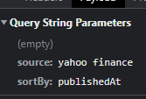

* **Expected result**

Responding ‘finding’

Showing a user news from Yahoo Finances

Responding ‘here is the news from Yahoo Finances’

Asking ‘do you want me to read the head lines’

* **Actual result**

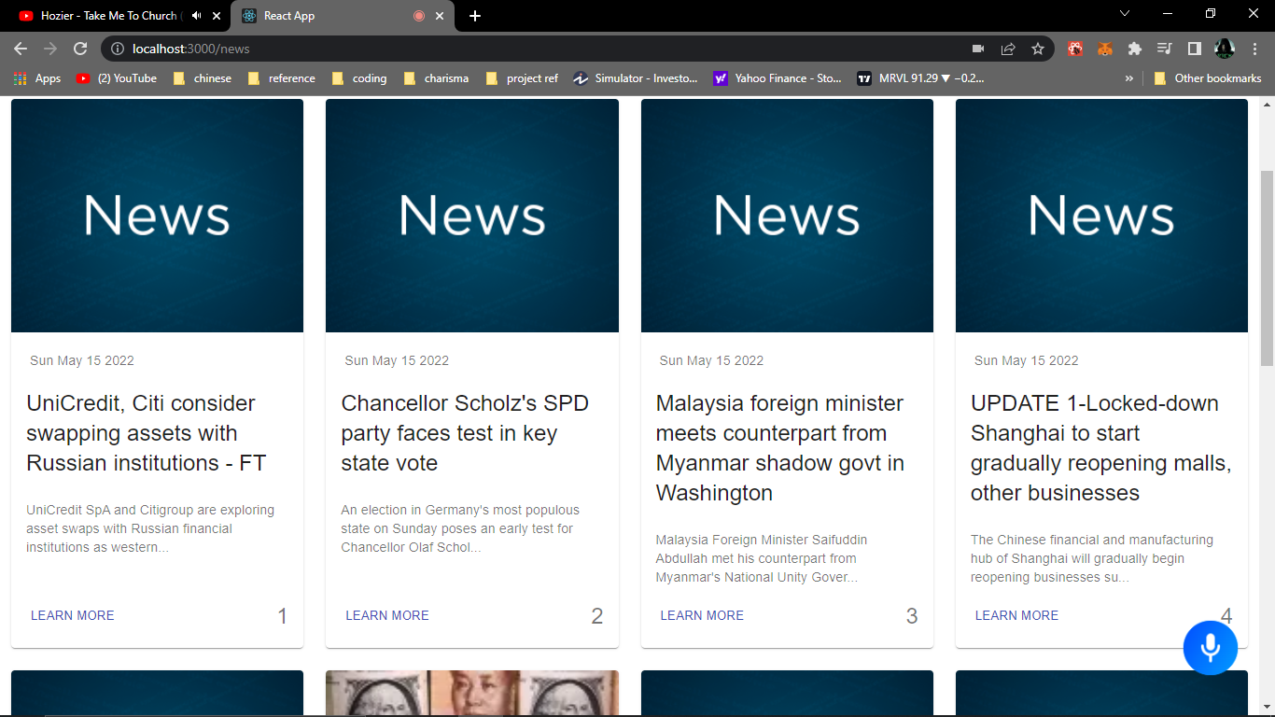

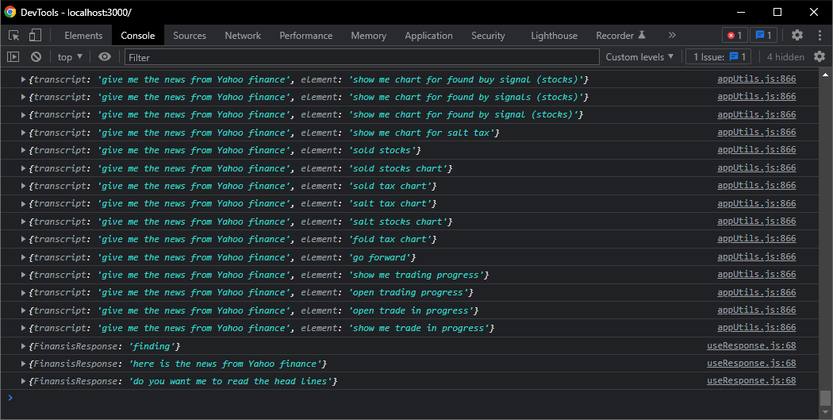

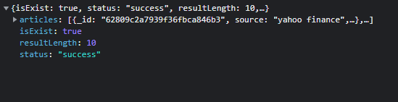

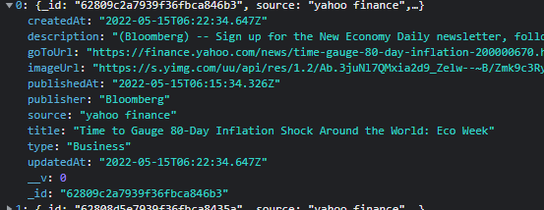

* **Conclusion**

**Pass**

* **Test case ID**

T2

* **Test case title**

Validate getting news by source Failing

* **Test steps**

- command ‘Give me the news from {CNN}’

* **Test data**

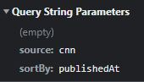

* **Expected result**

Responding ‘finding’

Responding ‘sorry, I didn't find news from {CNN}’

* **Actual result**

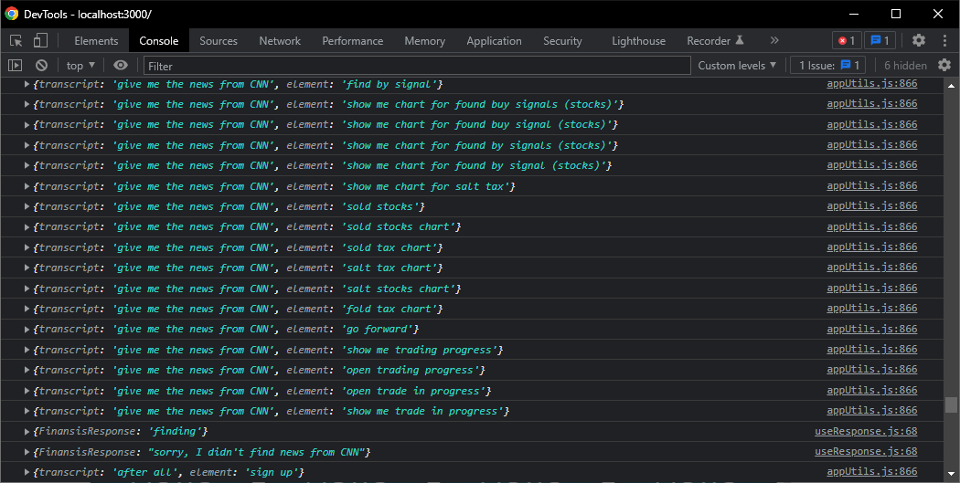

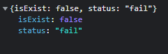

* **Conclusion**

**Pass**

* **Test case ID**

T3

* **Test case title**

Validate getting news by keyword in Title successfully

* **Test steps**

- command ‘what's up with {Shanghai}’

* **Test data**

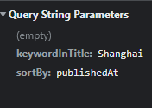

* **Expected result**

Responding ‘finding’

Showing a user news that has ‘Shanghai’ keyword in the head line

Responding ‘here is what's up with Shanghai’

Asking ‘do you want me to read the head lines’

* **Actual result**

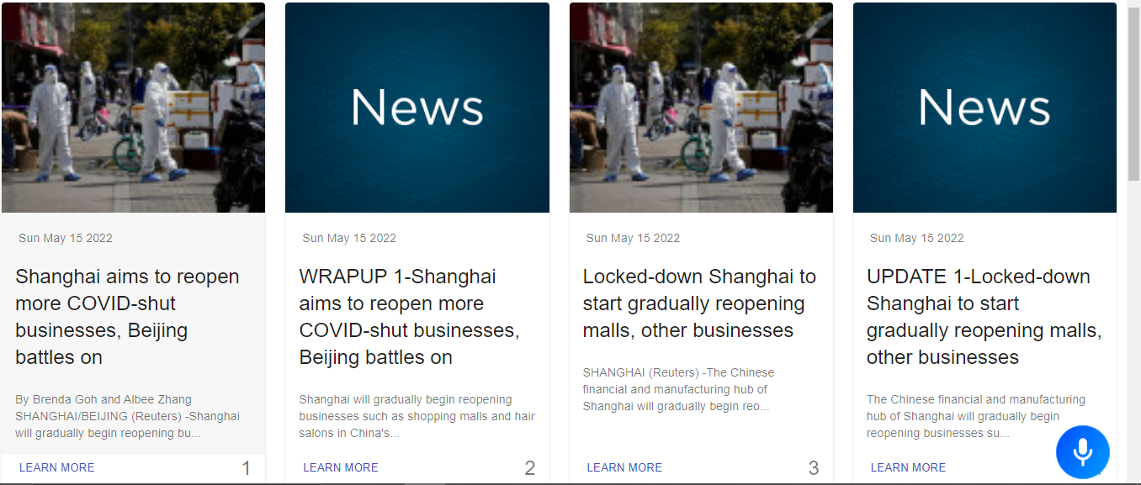

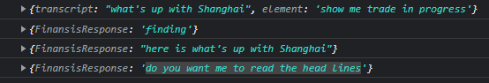

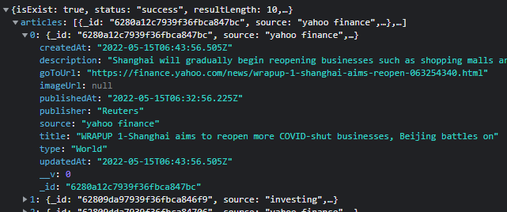

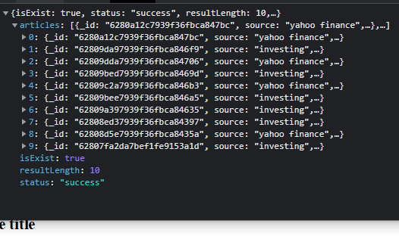

* **Conclusion**

**Pass**

* **Test case ID**

T4

* **Test case title**

Validate getting the latest News successfully

* **Test steps**

- command ‘give me the latest news’

* **Test data**

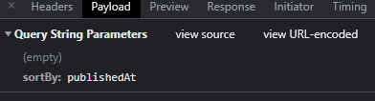

* **Expected result**

Responding ‘finding’

Showing a user the latest news

Responding ‘here is the latest news’

Asking ‘do you want me to read the head lines’

* **Actual result**

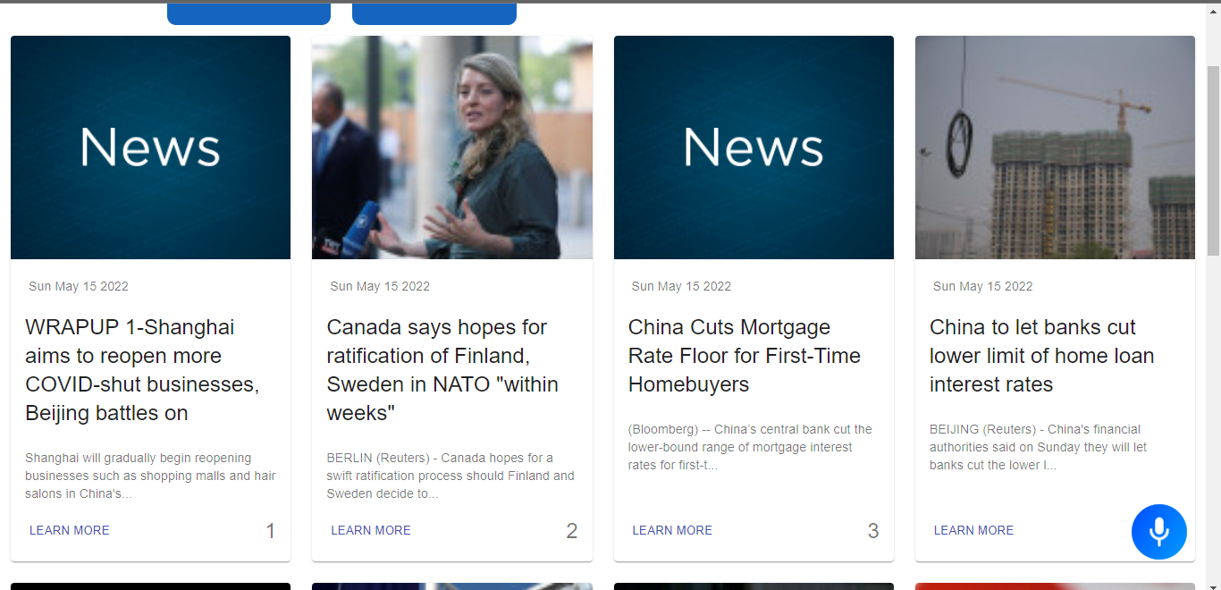

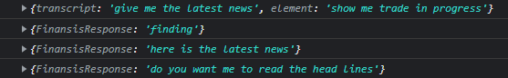

* **Conclusion**

**Pass**

* **Test case ID**

T5

* **Test case title**

Validate getting Top news successfully

* **Test steps**

- command ‘give me top stories’

* **Test data**

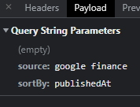

Google finance only shows top news by default

* **Expected result**

Responding ‘finding’

Showing a user top news

Responding ‘here is top news’

Asking ‘do you want me to read the head lines’

* **Actual result**

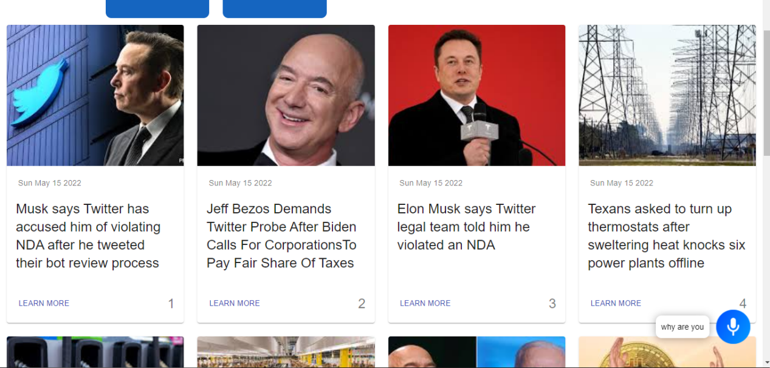

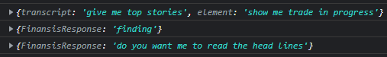

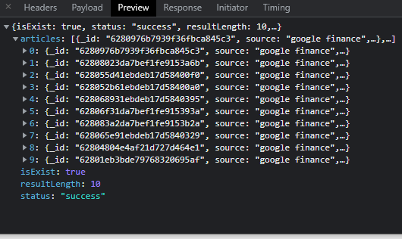

* **Conclusion**

**Failed**

Failed to Respond ‘here is top news’

* **Test case ID**

T6

* **Test case title**

Validate asking question in the database

* **Test steps**

- ask ‘what is market capitalization’

* **Test data**

what is market capitalization

* **Expected result**

- Opening popup window with the answer

- Responding ‘Market capitalization refers to how much a company is worth as determined by the stock market. It is defined as the total market value of all outstanding shares. value of all outstanding shares.’

- Closing popup window after answering the question

* **Actual result**

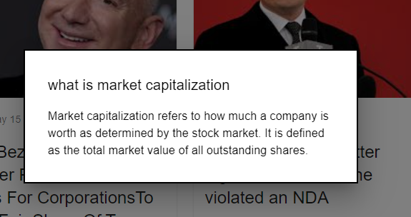

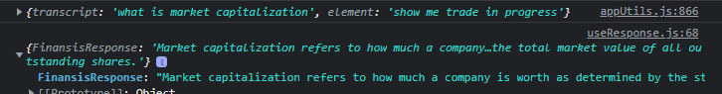

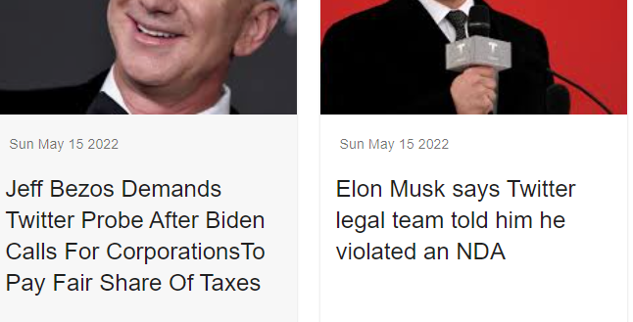

* **Conclusion**

**Pass**

* **Test case ID**

T7

* **Test case title**

Validate asking question not in the database

* **Test steps**

- ask ‘what is price-to-earning ratio’

* **Test data**

what is price-to-earning ratio

* **Expected result**

asking ‘do you want me to learn about what is price-to-earning ratio’

* **Actual result**



* **Conclusion**

**Pass**

* **Test case ID**

T8

* **Test case title**

Validate ‘yes’ answer for ‘do you want me to learn about what is price-to-earning ratio’ question

* **Test steps**

- answer ‘Yes’

* **Test data**

Yes

* **Expected result**

- Responding ‘give me a minute to find an answer’

- opening DuckDuckGo search engine using puppeteer

- searching ‘what is price-to-earning ratio investopedia’

- clicking at the first result

- scrap the answer from investopedia website

- save the question in the database

- Opening popup window with the answer

- Answering the question

- Closing popup window after answering the question

* **Actual result**

Before:

MongoDB:

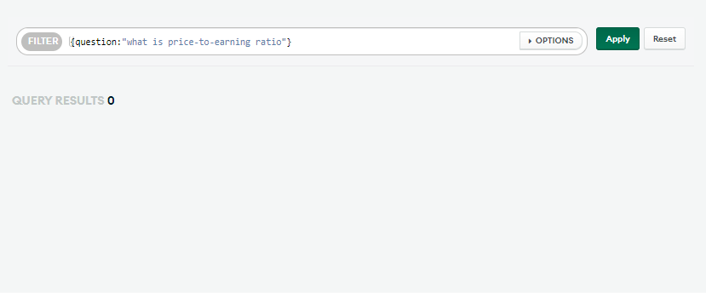



After:

Sending request to AUTO API’s ‘FindingAnswers endpoint”:

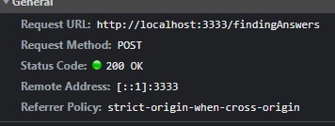

Searching in DuckDuckGo:

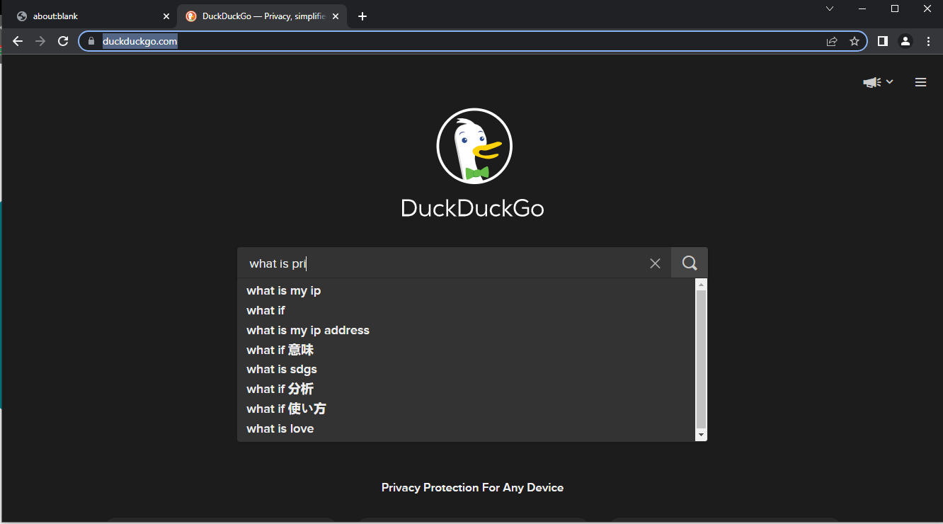

Response from AUTO API:

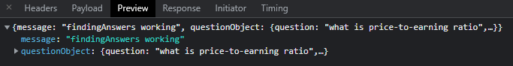

MongoDB:

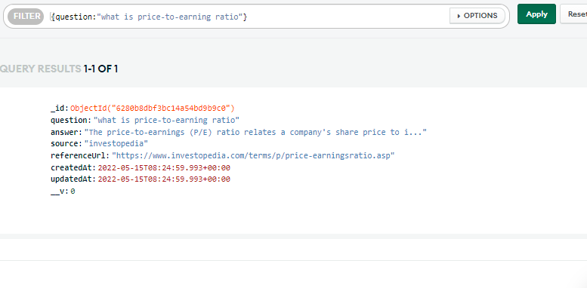

Opening popup window with the answer:

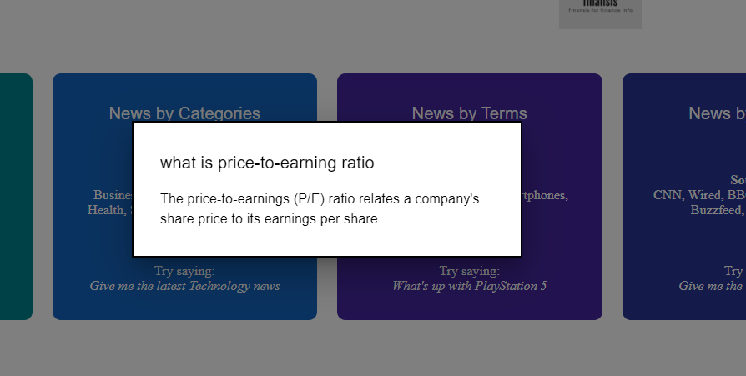



* **Conclusion**

Pass

* **Test case ID**

T9

* **Test case title**

Validate opening chart successfully

* **Test steps**

- command ‘open Apple chart’

* **Test data**

open Apple chart

* **Expected result**

- Opening popup window with list of stocks

- Asking ‘found the following stocks choose one by saying stock number 3 for example’

- Responding ‘opening AAPL chart’

* **Actual result**

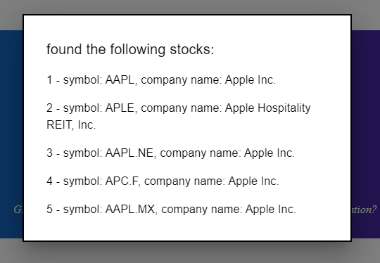





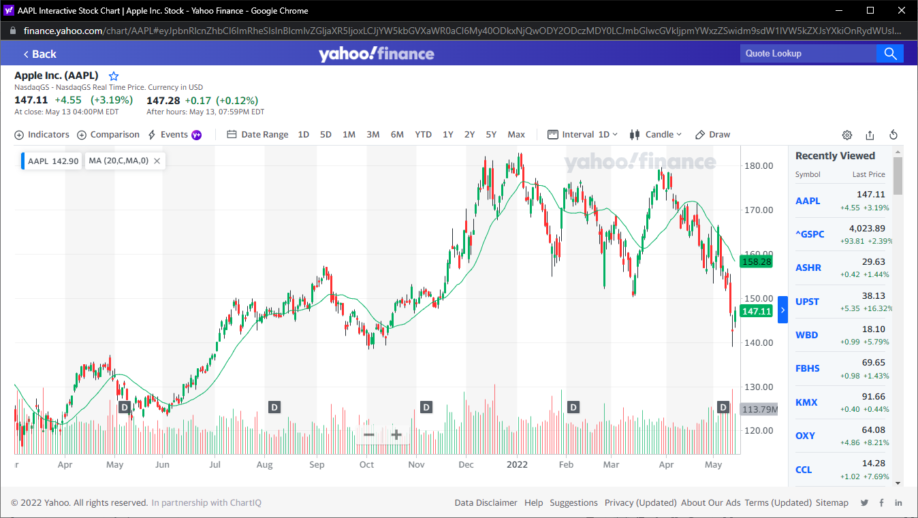

* **Conclusion**

pass

* **Test case ID**

T10

* **Test case title**

Validate opening multiple successfully

* **Test steps**

- command ‘open Apple and Tesla charts’

* **Test data**

open Apple and Tesla charts

* **Expected result**

Responding ‘opening Apple chart’

Opening Apple chart

Responding ‘opening Tesla chart’

Opening Tesla chart

* **Actual result**



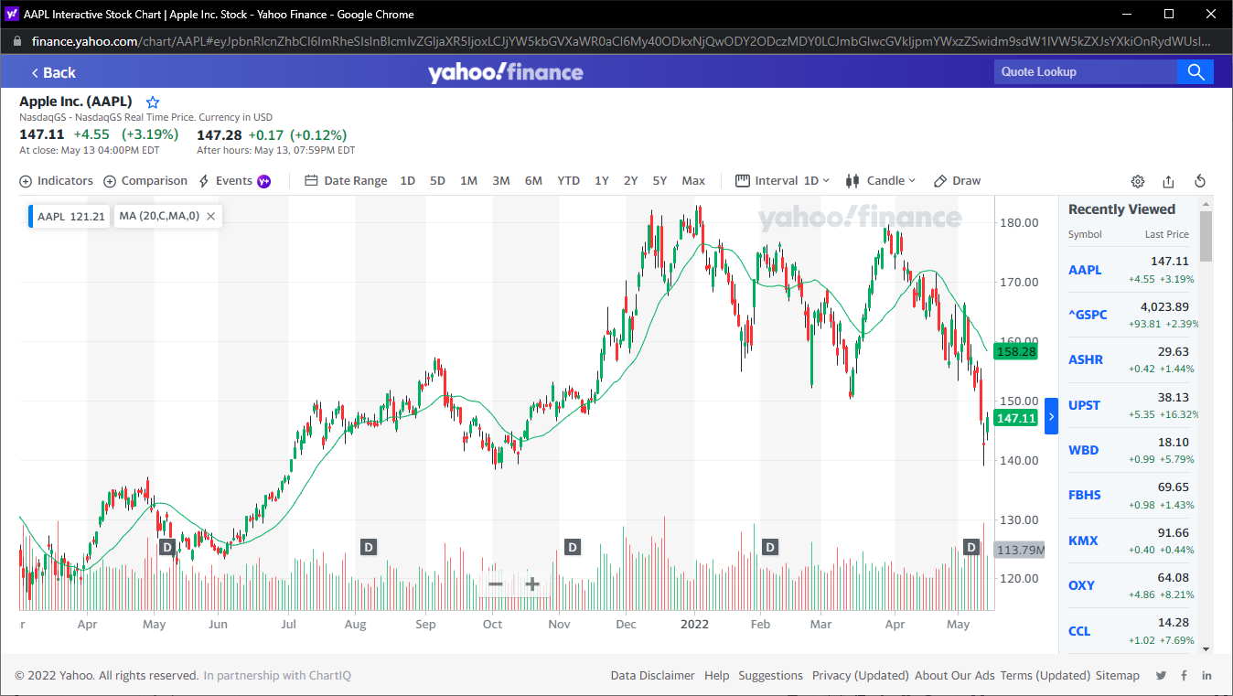



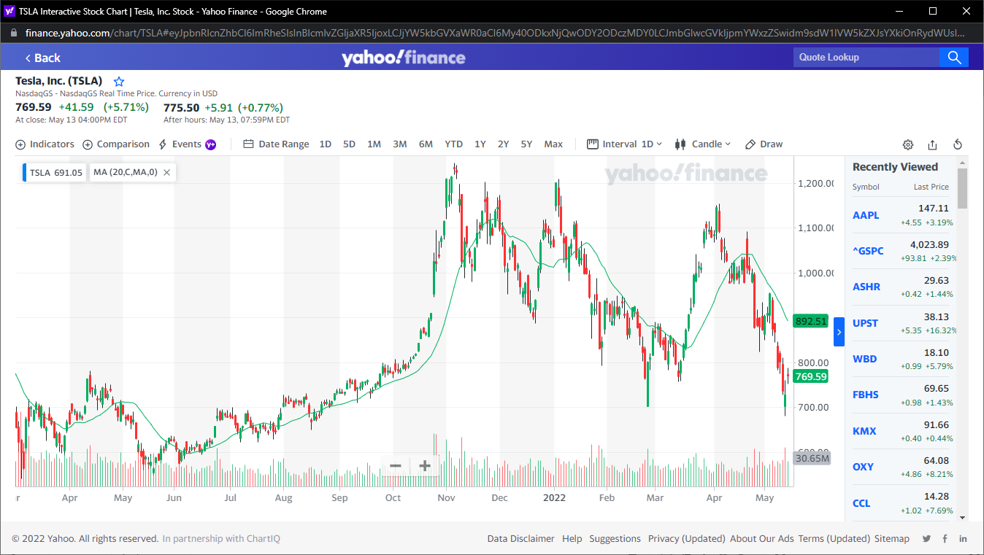

* **Conclusion**

pass

* **Test case ID**

T11

* **Test case title**

Validate getting the most activate stocks successfully

* **Test steps**

- command ‘give me the most active stocks’

* **Test data**

give me the most active stocks

* **Expected result**

Responding ‘here is the most actives stocks from yahoo finance’

Opening ‘Most activate stocks’ window

* **Actual result**



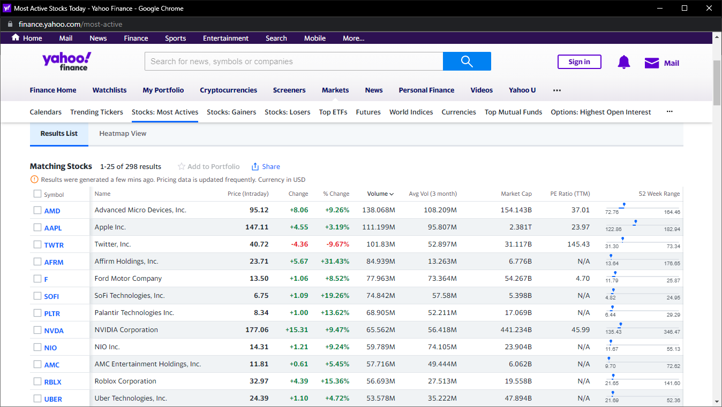

* **Conclusion**

pass

* **Test case ID**

T11

* **Test case title**

Validate opening chart with Finansis controller successfully

* **Test steps**

- command ‘open apple Chart with your control’

* **Test data**

open apple chart with your control

* **Expected result**

- Opening popup window with list of stocks

- Asking ‘found the following stocks choose one by saying stock number 3 for example’

- Responding ‘opening AAPL chart’

- Responding “loading the page will take seconds”

Opening AAPL chart using puppeteer

- Responding “the page is done loading”

* **Actual result**

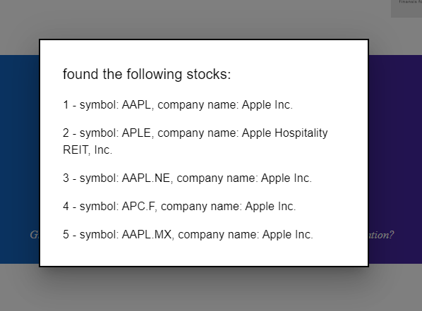



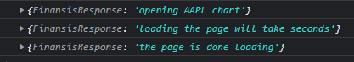

Send request to Auto API with the following payload:

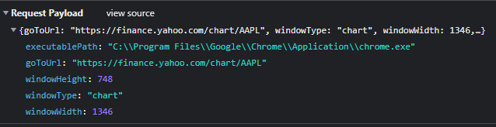

Auto API log:



Opened window:

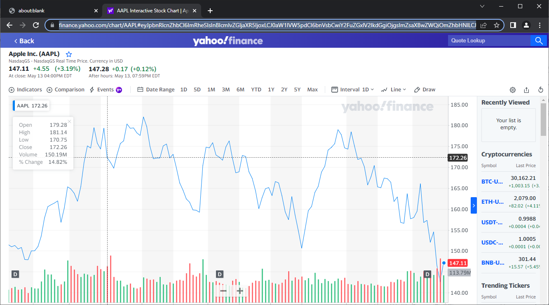

* **Conclusion**

pass

* **Test case ID**

T12

* **Test case title**

Validate zooming in a chart opened using puppeteer successfully

* **Test steps**

- command ‘zoom in’ five times

* **Test data**

zoom in

* **Expected result**

- Responding ‘zooming in’

- zooming the chart in

* **Actual result**

Before:

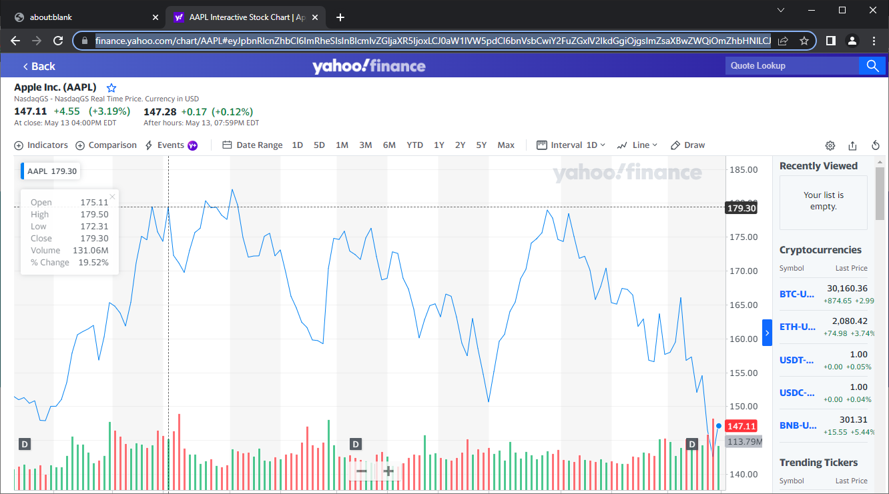

After:

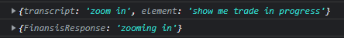

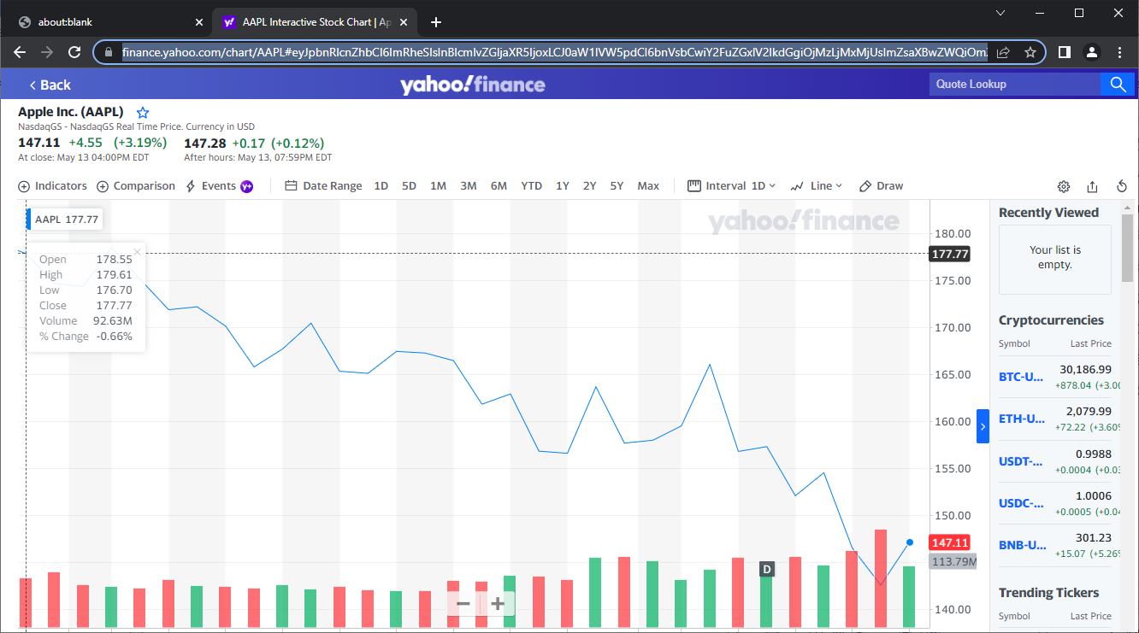

* **Conclusion**

pass

* **Test case ID**

T5

* **Test case title**

Validate getting Top news

* **Test steps**

- command ‘give me top stories’

* **Test data**



Google finance only shows top news by default

* **Expected result**

Responding ‘finding’

Showing a user top news

Responding ‘here is top news’

Asking ‘do you want me to read the head lines’

* **Actual result**



* **Conclusion**

**Failed**

Failed to Respond ‘here is top news’

* **Test case ID**

T5

* **Test case title**

Validate getting Top news

* **Test steps**

- command ‘give me top stories’

* **Test data**



Google finance only shows top news by default

* **Expected result**

Responding ‘finding’

Showing a user top news

Responding ‘here is top news’

Asking ‘do you want me to read the head lines’

* **Actual result**



* **Conclusion**

**Failed**

Failed to Respond ‘here is top news’

* **Test case ID**

T5

* **Test case title**

Validate getting Top news

* **Test steps**

- command ‘give me top stories’

* **Test data**



Google finance only shows top news by default

* **Expected result**

Responding ‘finding’

Showing a user top news

Responding ‘here is top news’

Asking ‘do you want me to read the head lines’

* **Actual result**



* **Conclusion**

**Failed**

Failed to Respond ‘here is top news’

* **Test case ID**

T5

* **Test case title**

Validate getting Top news

* **Test steps**

- command ‘give me top stories’

* **Test data**



Google finance only shows top news by default

* **Expected result**

Responding ‘finding’

Showing a user top news

Responding ‘here is top news’

Asking ‘do you want me to read the head lines’

* **Actual result**



* **Conclusion**

**Failed**

Failed to Respond ‘here is top news’

# Conclusion

thanks to every teacher who taught me something about computer science in Wenzhou or on the internet, thanks to each programmer on StackOverflow that help me or build technologies I used in this project, and special thanks to Wingo Laoshi that help me to come up with Finansis idea by telling me my old idea is not reasonable which was creating 'stock market production model' using machine learning. I will keep working on this project, and keep researching for good developers to build and improve the project, and one day we will take Finansis project from a final project for Degree of Bachelor to a real business that anyone interested in the stock market or making passive income can use Finansis.

## Future Goals For The System overview

* Improving UI design.
* Trading stocks with real money.
* Making the System online.
* Creating our own voice Recognition AI.
* Adding more commands to control the System.
* Making Finansis understand other Languages (Arabic and Chinese)
* Adding Smart Contracts

## Drawback of Existing system

* Existing system is failing in providing high security
* The website design is not good
* Trading stock with fake money.
* Finansis is offline (only run in developer localhost)
* Finansis Can only work in Chrome Browser
* Finansis can’t know that ‘what is’ and ‘what’s’ are the same

# REFERENCE

[1] Guru99 https://www.guru99.com/software-testing-introduction-importance.html.

[2] https://www.techtarget.com/searchcustomerexperience/definition/speech-recognition.

[3]https://www.datarobot.com/blog/what-is-natural-language-processing-introduction-to-nlp/

[4] Wikipedia https://en.wikipedia.org/wiki/Python_(programming_language).

[5] Wikipedia https://en.wikipedia.org/wiki/Front-end_web_development.

[6] Guru99 https://www.guru99.com/what-is-backend-developer.html.

[7] Investopedia https://www.investopedia.com/terms/a/algorithmictrading.asp.

[8] Youtube https://www.youtube.com/watch?v=p7HKvqRI_Bo.

[9] investopedia https://www.investopedia.com/ask/answers/155.asp.

[10] icicidirect <https://www.icicidirect.com/knowledge-center/article/risk-management-in-stock-market.>

[11]https://www.digitalocean.com/community/tutorials/how-to-use-node-js-modules-with-npm-and-package-json

[12] <https://www.emarketer.com/content/voice-assistant-and-smart-speaker-users-2020>

[13] [https://news-api-lovat.vercel.app/api/v1/news](https://news-api-lovat.vercel.app/api/v1/news).)

[14] <https://replit.com/@mHmdnwr/Chromium-Advanced-5ad#main.py>